Helwan university

Faculty of engineering

* Prepared by:
* Mahmoud Ehab Mahmoud Abdeen.
* Ahmed Khaled Mohana Tohamy.
* Mariam Mohamed Abdelmonem Ismail.

Under supervision of

DR/Manal showman

Table of Contents:

Team members: 5

List of Figures: 5

1. Preface: 7

1.1 Document Purpose: 7

1.2 Target Users: 7

1.3 Revision History: 7

2. Introduction: 8

2.1 Purpose: 8

2.2 Scope: 8

2.3 Overview: 9

3. Glossary: 9

3.1 Acronyms, definitions, and abbreviations: 9

4. System Users: 10

4.1 System stakeholders: 10

4.2 Users objectives: 10

5. User Requirements definitions: 11

5.1 System Functions: 11

5.2 Constraints: 12

6. System Architecture: 12

7. System Functional requirements: 13

7.1 Forgot password: 13

7.2 View users activity table: 13

7.3 View login attempts table: 13

7.4 Search through user activity & login attempts tables: 13

7.5 View users table: 13

7.6 Search through user table: 13

7.7 Add new user: 13

7.8 Update existing user information: 14

7.9 Delete existing user information: 14

7.10 Delete existing user table: 14

7.11 View project table & analyze project progress: 14

7.12 Search through project table: 14

7.13 Create project & assign project to users: 14

7.14 View bug table: 14

7.15 Search through bug table: 14

7.16 Add bug details (types and severity): 14

7.17 View rate table: 14

7.18 Reset password: 14

7.19 View assigned bugs table that its status is in progress: 14

7.20 Update bug status: 14

7.21 View assigned projects table: 14

7.22 Search through assigned projects table: 14

7.23 View assigned bugs table regardless to its status: 14

7.24 View assigned bugs table that its status is to be tested: 15

7.25 Search through assigned bugs table: 15

7.26 View assigned users of each project: 15

7.27 View bugs table for specific project: 15

7.28 Search through bugs table of a specific project: 15

7.29 Report bug: 15

7.30 Update bug details: 15

7.31 Delete bug: 15

7.32 View an overview of bugs status in a specific project: 15

8. Interface requirements: 15

8.1 User interfaces: 15

8.2 Software Interfaces: 27

9. Non-functional requirements: 27

9.1 Availability: 27

9.2 Security: 27

9.3 Maintainability: 27

9.4 Portability: 27

9.5 Usability: 27

9.6 Efficiency 28

10. System Models and Diagrams: 28

11. System Evolution: 66

12. Future Work: 66

13. Time Plan: 67

13.1 Work Breakdown Structure: 67

13.2 Gantt chart: 67

14. References: 68

# Team members:

|  |  |  |
| --- | --- | --- |
| Name | Code | Work in SRS |
| Ahmed Khaled Mohana Tohamy. | 20026 | * Introduction. * System architecture. * System non-functional requirements. * Glossary. |
| Mahmoud Ehab Mahmoud Abdeen. | 20010 | * Preface. * User requirements definitions. * Interface requirements. * Glossary. |
| Mariam Mohamed Abdelmonem Ismail | 20047 | * System users. * System functional requirements. * System evolution. * Future work. * Work Plan. * Glossary. |

# List of Figures:

Figure 1 : System Modules hierarchy 8

Figure 2 : System Functions hierarchy 9

Figure 3 : System Architecture 13

Figure 4 : Loading page 15

Figure 5 : Login Page 16

Figure 6 : Admin page: Activity &login attempts table 16

Figure 7 : Admin page: Users table 17

Figure 8 : Admin Page: User information 17

Figure 9:Admin Page: Projects table 18

Figure 10 : Admin Page: Project Information 18

Figure 11 : Admin Page: Bugs Table 19

Figure 12 : Admin Page: Bug Information 19

Figure 13 : Rating Page 20

Figure 14 : Developer Page: Dashboard 20

Figure 15 : Developer Page: Show bug details 21

Figure 16 : Developer Page: Projects Table 21

Figure 17 : Developer Page: Bugs Table 22

Figure 18 : Developer Page: Change bug status 22

Figure 19 : Tester Page: Dashboard 23

Figure 20: Tester Page: Bug Information 23

Figure 21 : Tester Page: Project Table 24

Figure 22:Tester Page: Assigned people to the same project 24

Figure 23:Tester Page: Bugs Panel 25

Figure 24:Tester Page: View all the bugs in a specific project 25

Figure 25:Tester Page: View Bug Details or add new bug 26

Figure 26:Tester Page: View Overview of Bugs Status 26

Figure 27:Rating Page 27

Figure 28:context diagram 28

Figure 29 : Class diagram 28

Figure 30 : Use case diagram 29

Figure 31 : Work Break Down Structure 67

Figure 32 : Gannt chart 68

Figure 33 : Updated Gantt Chart 68

# Preface:

## Document Purpose:

* Through this document, a complete and detailed specification of the Bug Tracker System will be provided, making it possible to understand the ins and outs of the software and what each user will be able to achieve by using it.
* In the first section, an overview of the system will be elaborated upon, and then each part of the system will be discussed in more detail in the following sections.

## Target Users:

* This document is authored by system engineers based on the requirement obtained from the senior software engineers, developers and testers of the company that issued the development of the system.
* The document is to be approved and acknowledged by the CEO, senior SW engineers, developer, testers, and the crew working on developing the project.

## Revision History:

|  |  |  |  |
| --- | --- | --- | --- |
| **Version** | **Author** | **Description** | **Date** |
| **0.1** | All members of the team | Initial | 23-7-2022 |
| **0.2** | Mariam Mohamed | Some functional requirements changes | 3-8-2022 |
| **0.3** | Mahmoud Ehab | Some changes in system functions | 6-8-2022 |
| **0.4** | Ahmed Khaled | Some changes in non-functional requirements | 9-8-2022 |
| **0.5** | Mariam Mohamed | Work plan is added | 12-8-2022 |
| **0.6** | Mahmoud Ehab | Minor changes in system functional requirements | 21-8-2022 |
| **0.7** | Mahmoud Ehab | Class diagram is updated | 21-8-2022 |
| **0.8** | Ahmed Khaled | Use case diagram is updated | 21-8-2022 |
| **0.9** | Ahmed Khaled | Small change in stakeholders | 2-9-2022 |
| **1.0** | Mariam Mohamed | User interface is updated | 2-9-2022 |

# Introduction:

## Purpose:

* purpose of the software is to track bugs and allow the end user to manage bugs and store them if they ever appear in other projects.

## Scope:

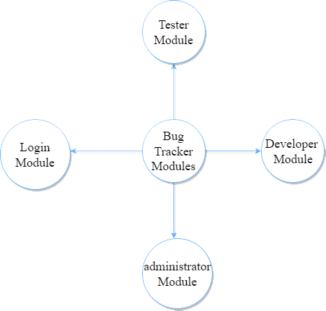

Figure 1 : System Modules hierarchy

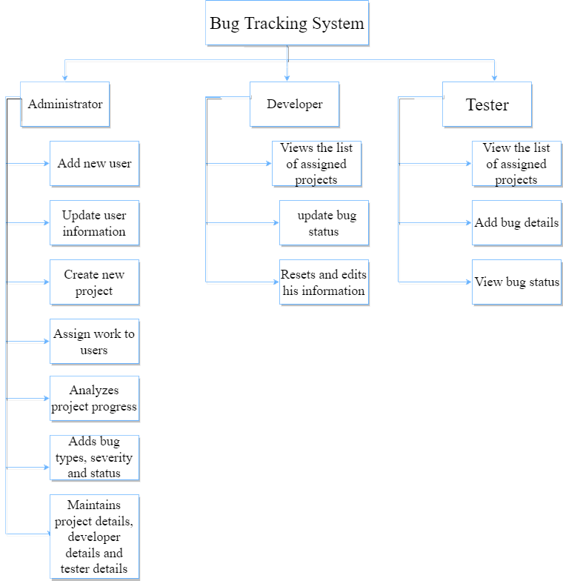

Figure 2 : System Functions hierarchy

## Overview:

* The document is organized as follows:
* an overview description of the bug tracker system and its high-level functions are presented (section 2.1 and 2.2).
* section 4 state types of users who can use bug tracker.
* Section 5 in the document provides user requirement definitions.
* Section 6 in the document provides system architecture.
* Section 7 in the document provides a detailed description of the system functions and requirements.
* Section 8 in the document provides interface requirement.
* Section 9 in the document provides the system non functions and requirements.
* Section 10 presents some helping information and diagrams that will facilitate the understanding of the contents.
* Section 11 in the document provides system evolution.
* Section 12 in the document provides future work.
* Section 13 in the document provides time plan.
* Section 14 in the document provides appendices.
* Finally, Section 15 in the document provides references.

# Glossary:

## Acronyms, definitions, and abbreviations:

* **FOEHU**: Faculty of Engineering, Helwan University.
* **BTS:** Bug Tracker System.
* **User:** Developer or tester who uses the application.

# System Users:

## System stakeholders:

* System Engineer.
* Responsible for gathering requirements.
* Responsible for development.
* Responsible for support.
* Administrator:
* Adds new users.
* Updates users’ information.
* Deletes users.
* Creates projects.
* Assigns projects to users.
* Deletes projects.
* Adds bug types and severity.
* Monitors user activity.
* Views failed login attempts.
* Developer:
* Views the list of assigned projects.
* Responsible for updating bug status.
* Resets and edits his information like passwords.
* Tester:
* View the list of assigned projects.
* Adds bug details.
* View bug status.

## Users objectives:

* System Engineer.
* Gains experience in software engineering and developments.
* Administrator:
* Follows up on the work of the users.
* Developer:
* Simplification in finding the assigned work.
* Prevent assigned work mixing.
* Work in an organised environment.
* Tester:
* Simplification in finding the assigned work.
* Prevent assigned work mixing.
* Work in an organised environment.

# User Requirements definitions:

## System Functions:

* **Login:**
  + 1. Forgot password.
* **Administrator:**
  + 1. View user activities table.
    2. View login attempts table.
    3. Search through user activity & login attempts tables.
    4. View users table.
    5. Search through users table.
    6. Add new user.
    7. Update existing user information.
    8. Delete existing user information.
    9. Delete all user.
    10. View projects table.
    11. Search through project table.
    12. Create projects & Assign project to user.
    13. View bugs table.
    14. Add bug details (types and severity).
    15. View rate table.
* **Developer:**
  + 1. Reset password.
    2. View assigned bugs that its status is in progress.
    3. Update bug status (from in progress to to be tested).
    4. View assigned projects table.
    5. Search through assigned project table.
    6. View assigned bugs table.
    7. View all assigned bugs regardless to its status.
* **Tester:**
  + 1. View assigned bugs table that its status is to be tested.
    2. Search through assigned bugs table.
    3. Update bug status (from to be tested into closed).
    4. View assigned projects table.
    5. Search through projects table.
    6. View assigned users of each project assigned to him.
    7. View bugs table for specific project.
    8. Search through bugs table for specific project.
    9. Report bug.
    10. Update bug details.
    11. Delete bug.
    12. View an overview of bugs status in specific project.

## Constraints:

1. Company Policies:
   * Users must be limited by permissions to insure data confidentiality.
2. Cultural Constraints:
   * Code must follow company standards.
3. Technological Limitations:
   * Integration with Git is required to allow database synchronization.

# System Architecture:

* We use database to connect between all users of the system and store information.

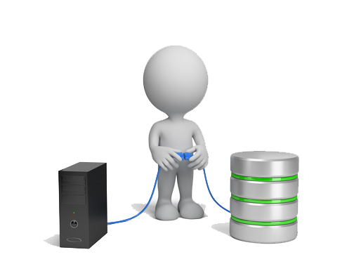

Figure 3 : System Architecture

# System Functional requirements:

## Forgot password:

* If anyone of the users forgot their passwords, they could ask for a new password and the Administrator will replace their old passwords with new ones.

## View users activity table:

* **The administrator** will have the ability to view the activities of each user to track the system, monitor the behavior of and progress of users, and change passwords solicited by password reset requests.

## View login attempts table:

* **The administrator** will view the table of login attempts which includes all the requests of users who forgot their passwords and need to change it, or attempts others to breach the system through the login page.

## Search through user activity & login attempts tables:

* **The administrator** can Search through user activity & login attempts table.

## View users table:

* Only **the administrator** can view all the users in the system (company).

## Search through user table:

* The administrator can Search through user table by (name & role).

## Add new user:

* **Only the administrator** can add a new user to the system by adding specific information (Username – Password – Role – ID).

## Update existing user information:

* **The administrator** can update user information.

## Delete existing user information:

* **The administrator** can delete existing user information.

## Delete existing user table:

* **The administrator** can delete existing user table.

## View project table & analyze project progress:

* **The administrator** will have the ability to view a table of all projects in the system and analyze their progress by following the dates.

## Search through project table:

* **The administrator** can Search through project table by (name).

## Create project & assign project to users:

* **Only the administrator** can create a new project to the system and assign to this project a specific number of users be it developers or testers.

## View bug table:

* **The administrator** can view a table of bugs that are created by the tester & assign a developer to solve this bug.

## Search through bug table:

* **The administrator** can Search through project table by (name, severity & type).

## Add bug details (types and severity):

* **The administrator** can add bug types and severity.

## View rate table:

* **The administrator** can view rate table.

## Reset password:

* **Developers** have the access to reset their passwords, but the administrator will receive a notification when this action happens.

## View assigned bugs table that its status is in progress:

* **Developers** have the access to view a table of assigned bugs which status is in progress and needs to be completed.

## Update bug status:

* **Developers:** The developers can update the assigned bug status from in progress into to be tested after adding the solution of this bug.
* **Testers:** The testers can update the assigned bug status from to be tested into closed after reviewing the solution of the developer and make sure that it’s the right solution.

## View assigned projects table:

* **Developers & Testers** can view assigned projects table.

## Search through assigned projects table:

* **Developers & Testers** can view assigned projects table by (name – id).

## View assigned bugs table regardless to its status:

* **Developers** can view assigned bugs table regardless to its status and it’s used as a reference for the developer.

## View assigned bugs table that its status is to be tested:

* **Testers** have the access to view a table of assigned bugs which status is to be tested and needs to be completed.

## Search through assigned bugs table:

* **The tester** can Search through project table by (id & name).

## View assigned users of each project:

* **Testers** can view assigned users table of each project that is assigned to him.

## View bugs table for specific project:

* **Only testers** have the access to view bugs table for specific project.

## Search through bugs table of a specific project:

* **Testers** have the access to Search through bugs table of specific project by (id, name , severity & type).

## Report bug:

* **Only testers** have the access to create a new bug and add the details of this bug.

## Update bug details:

* **Only testers** have the access to update bug details.

## Delete bug:

* **Only testers** have the access to delete the bug.

## View an overview of bugs status in a specific project:

* **Only testers** have the access to view an overview of bugs status in a specific project in pie chart and cards.

# Interface requirements:

## User interfaces:

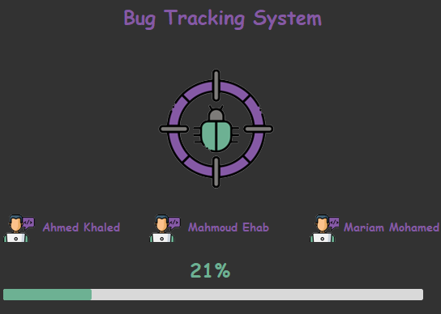

Figure 4 : Loading page

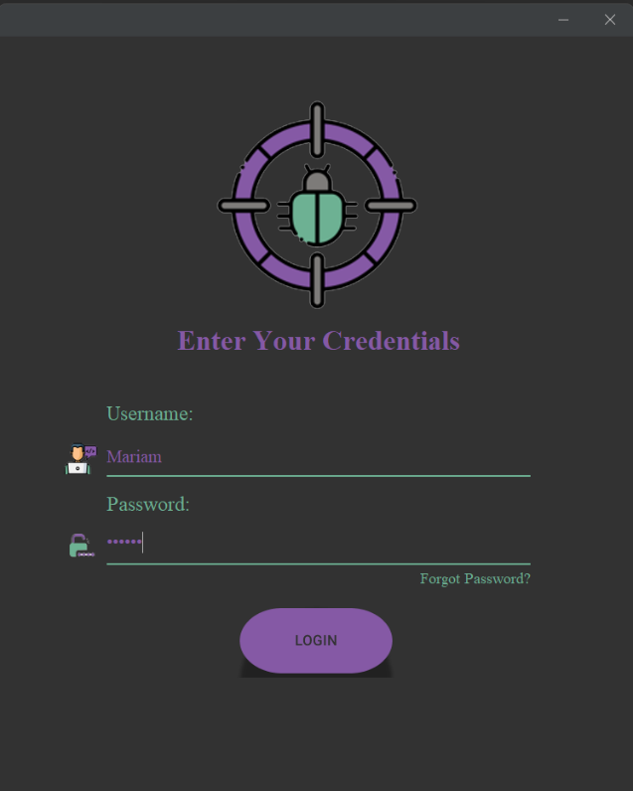

Figure 5 : Login Page

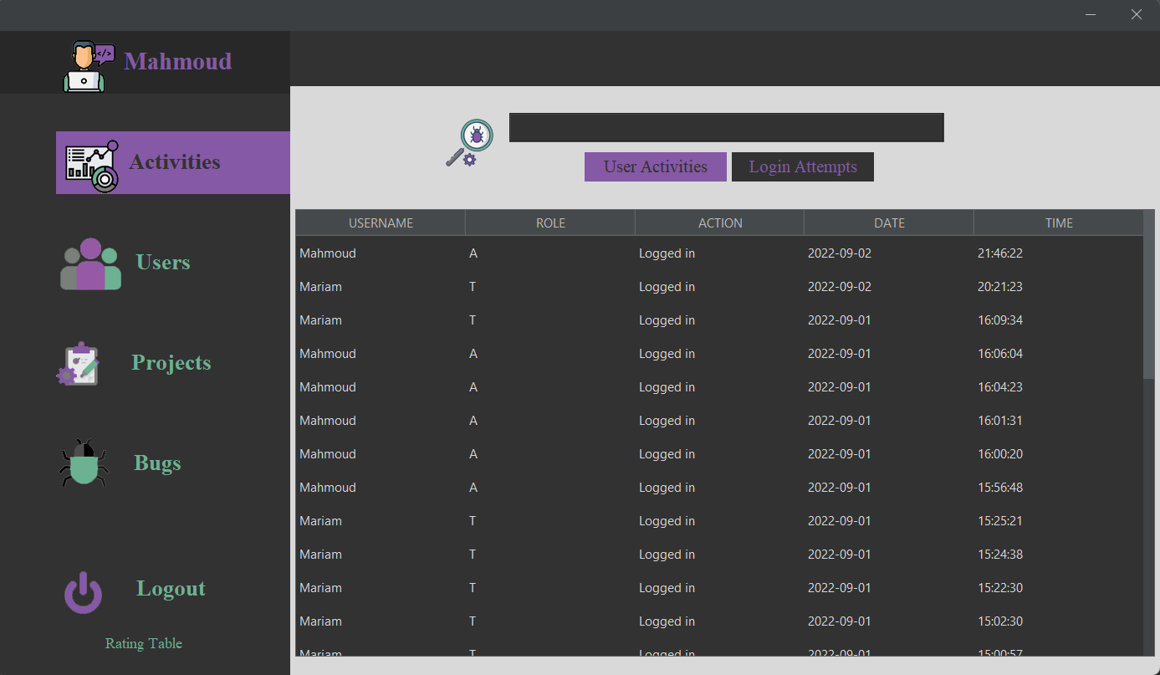

Figure 6 : Admin page: Activity &login attempts table

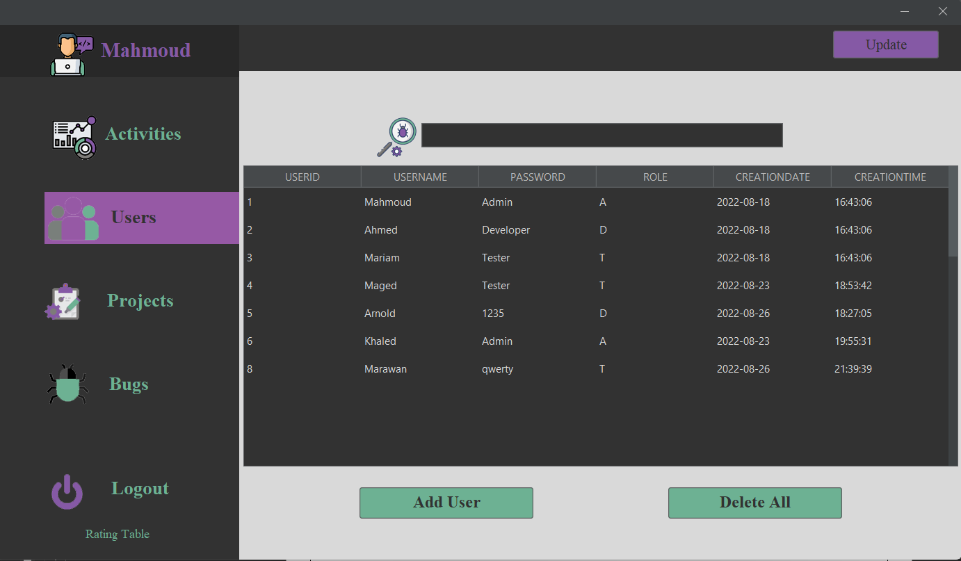Figure 7 : Admin page: Users table

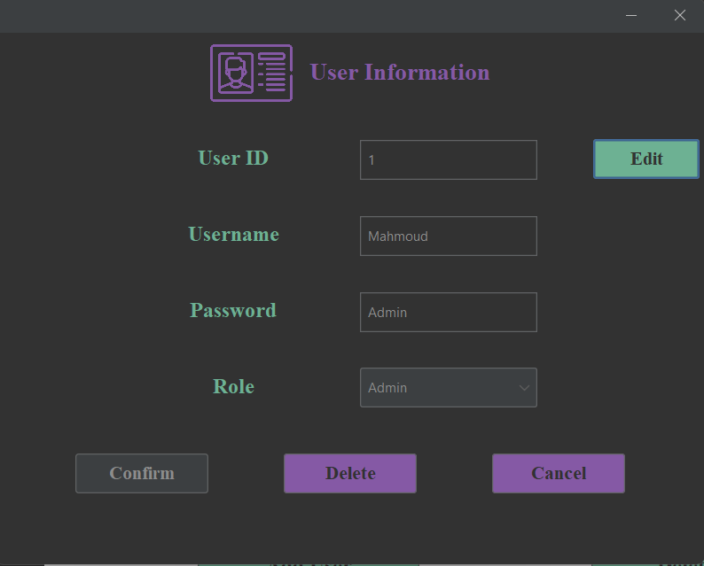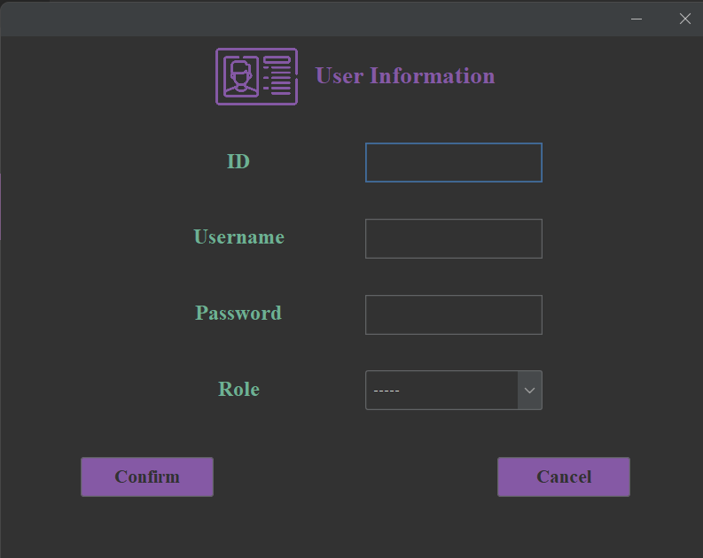

Figure 8 : Admin Page: User information

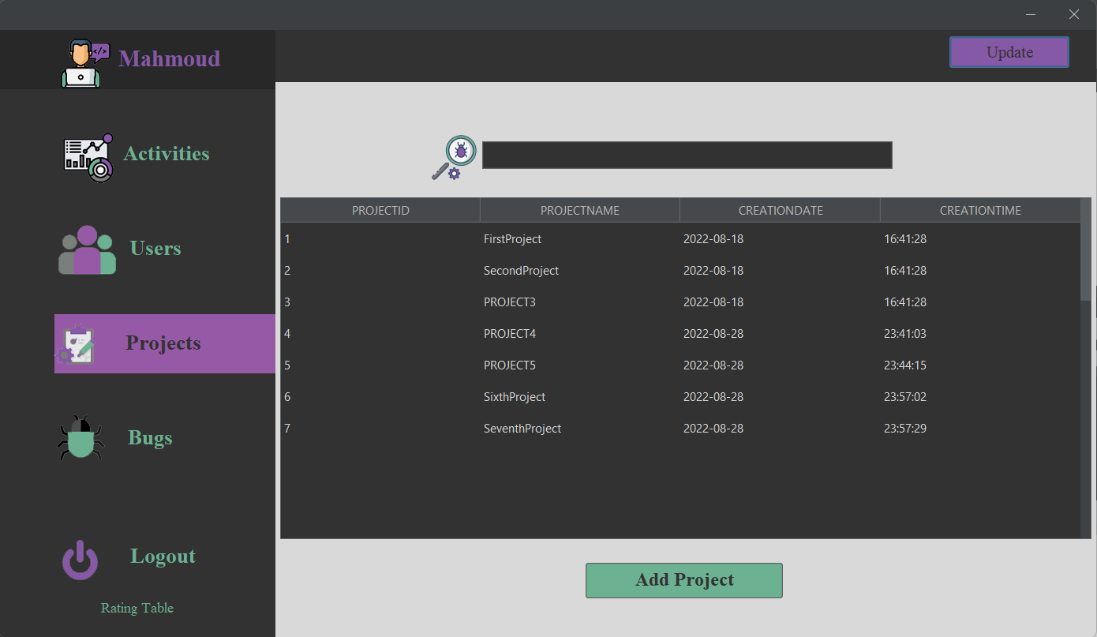

Figure 9:Admin Page: Projects table

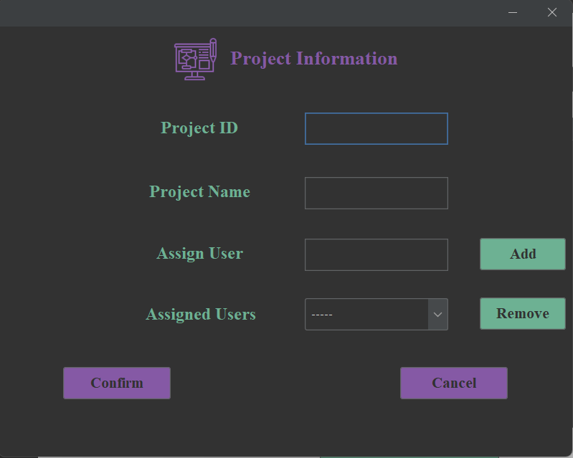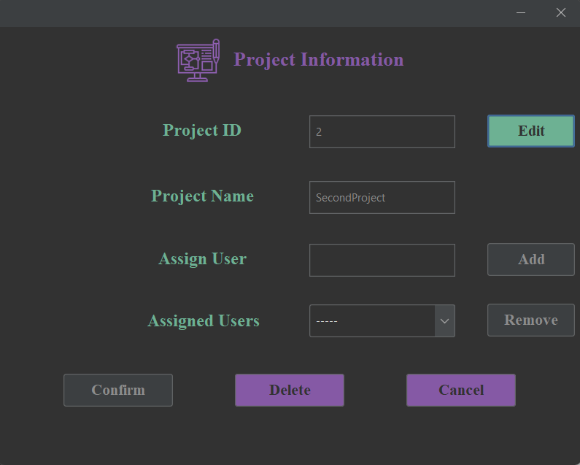

Figure 10 : Admin Page: Project Information

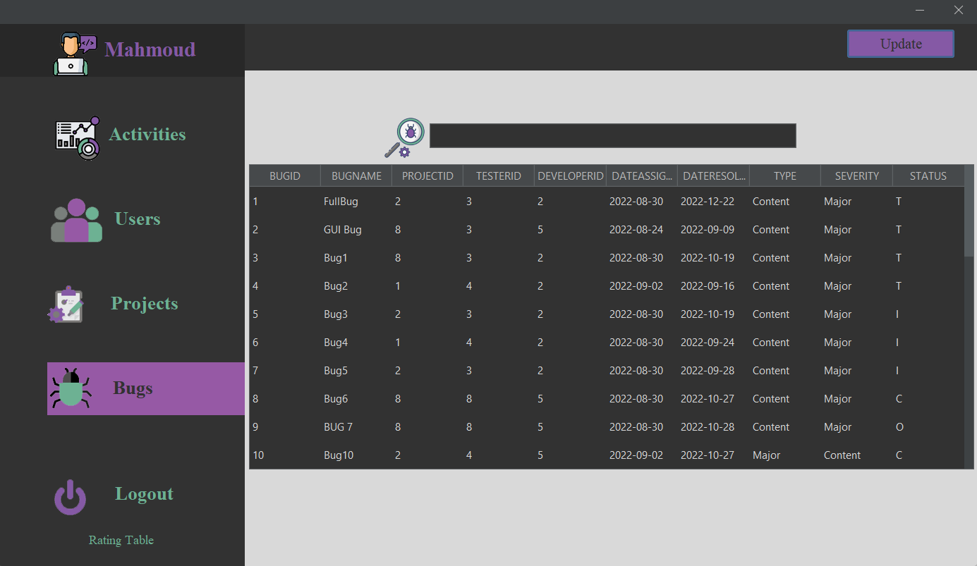

Figure 11 : Admin Page: Bugs Table

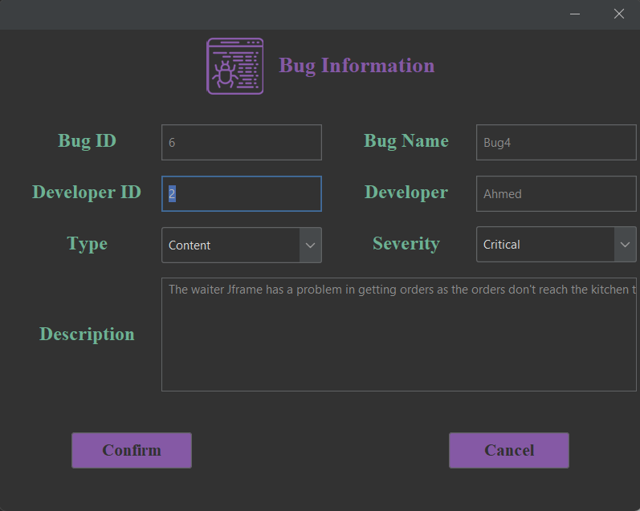

Figure 12 : Admin Page: Bug Information

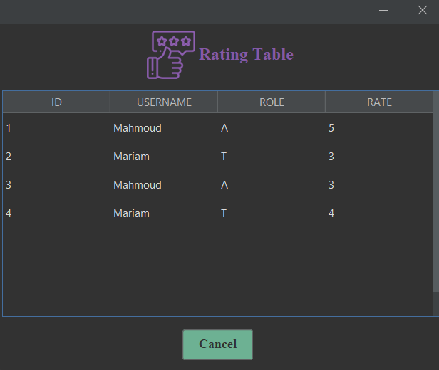

Figure 13 : Rating Page

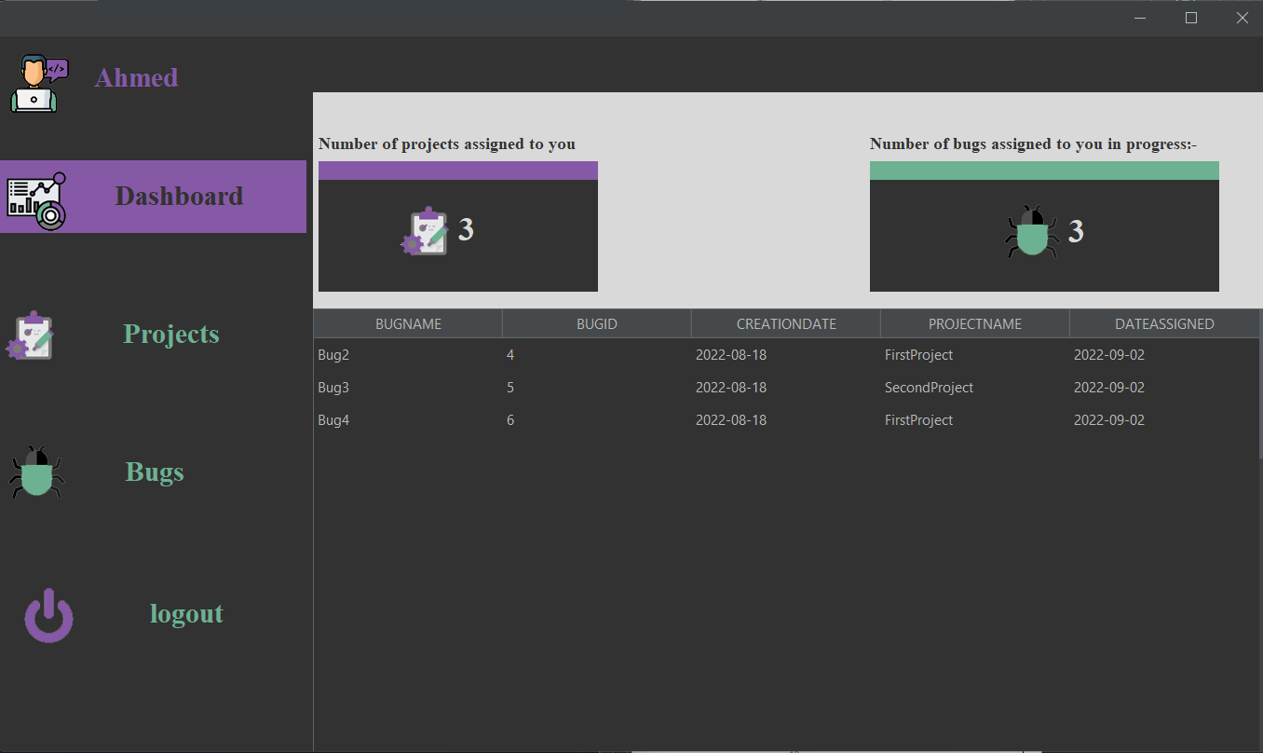

Figure 14 : Developer Page: Dashboard

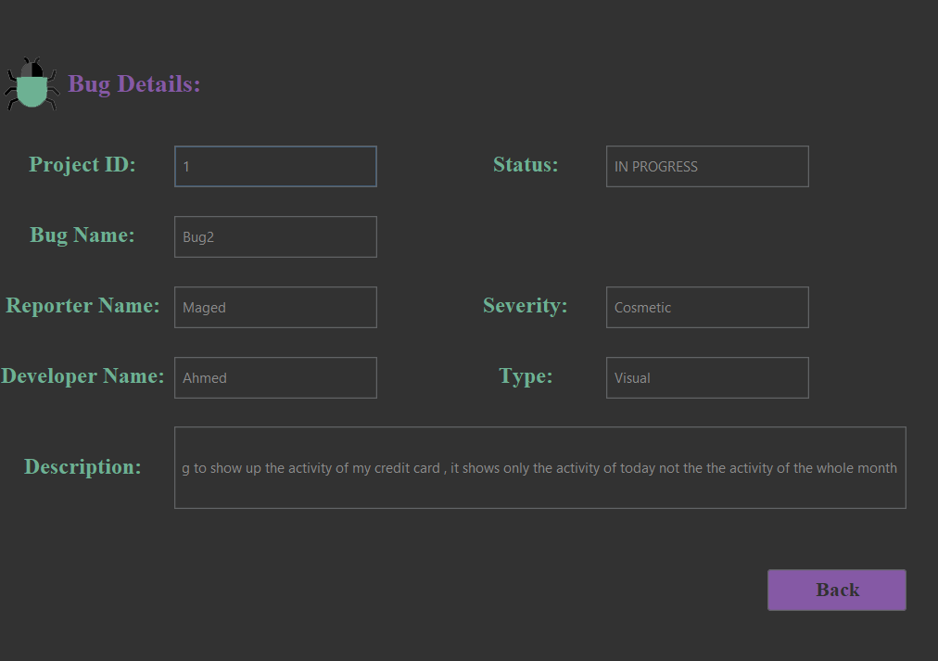

Figure 15 : Developer Page: Show bug details

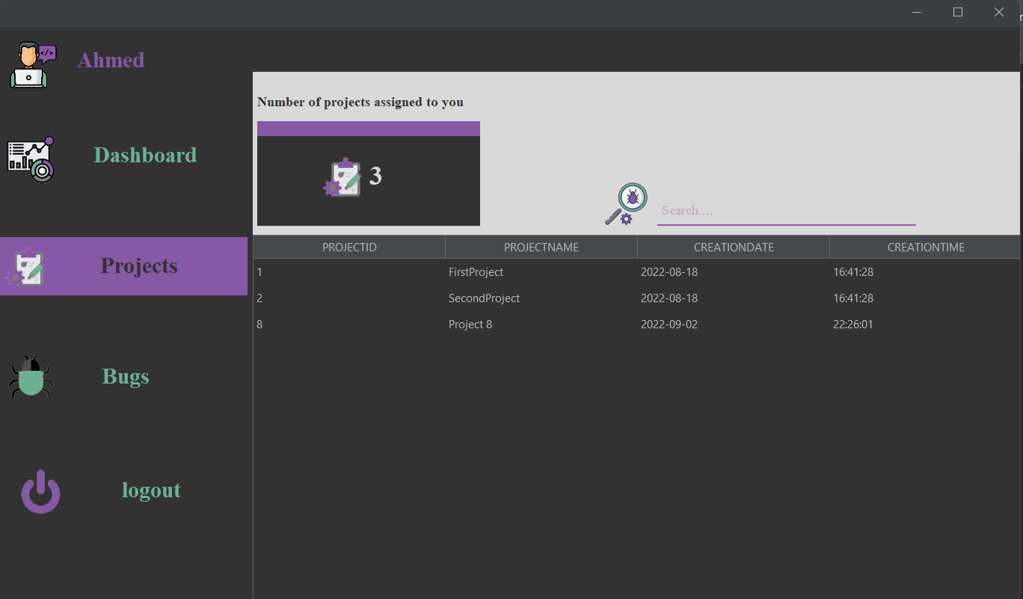

Figure 16 : Developer Page: Projects Table

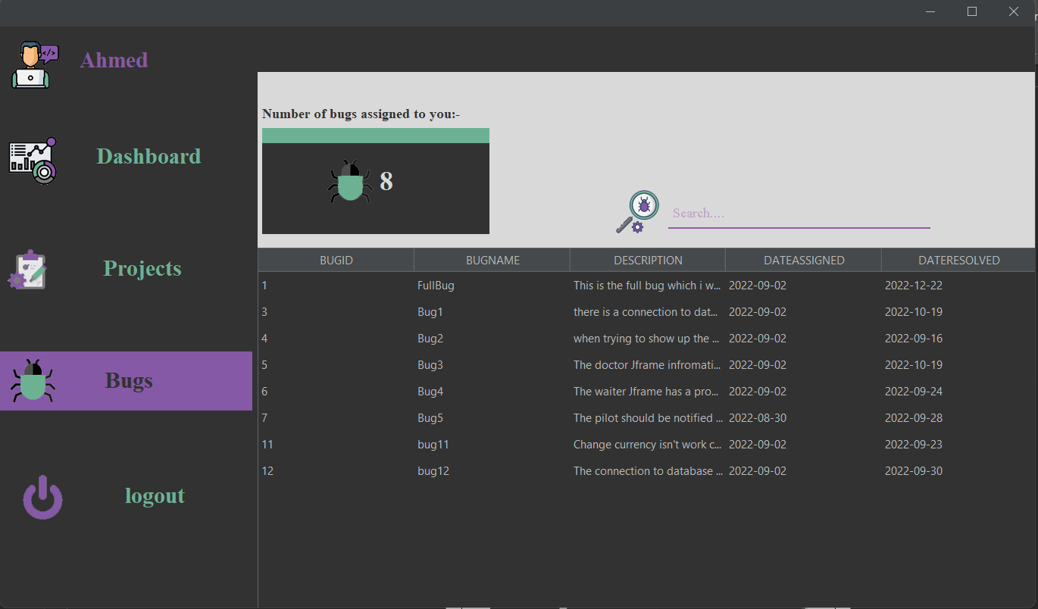

Figure 17 : Developer Page: Bugs Table

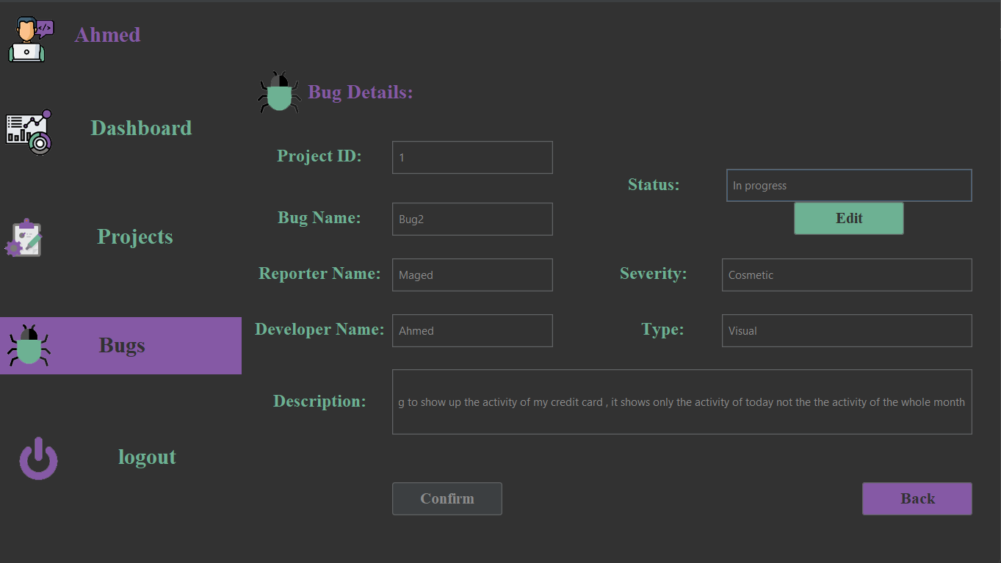

Figure 18 : Developer Page: Change bug status

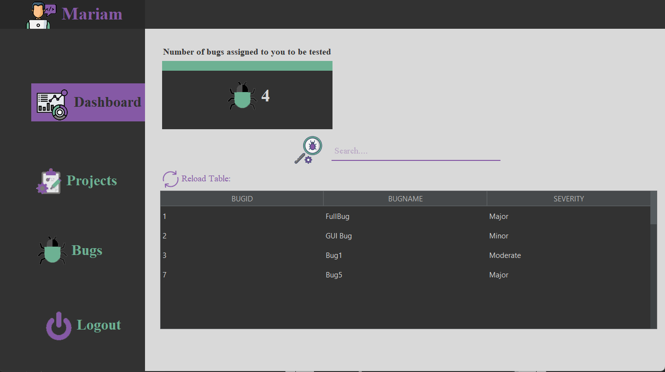

Figure 19 : Tester Page: Dashboard

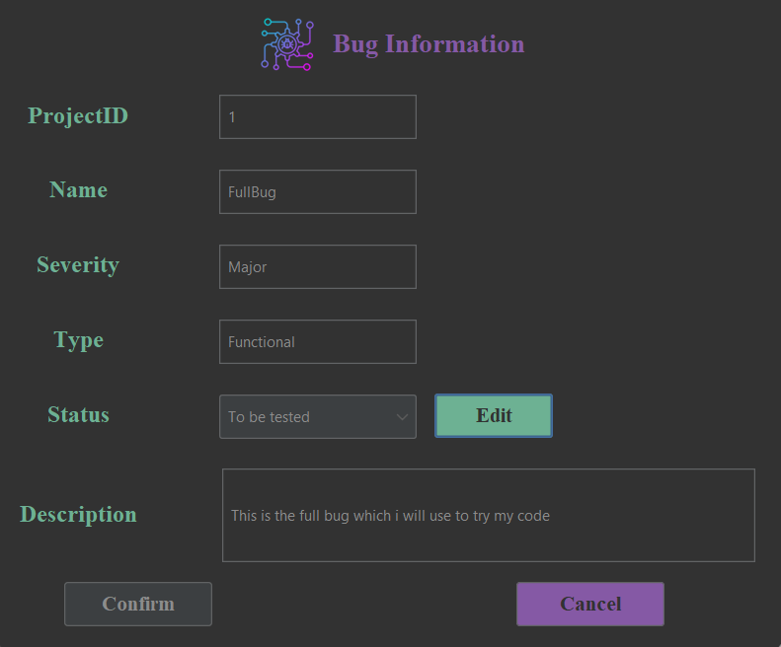

Figure 20: Tester Page: Bug Information

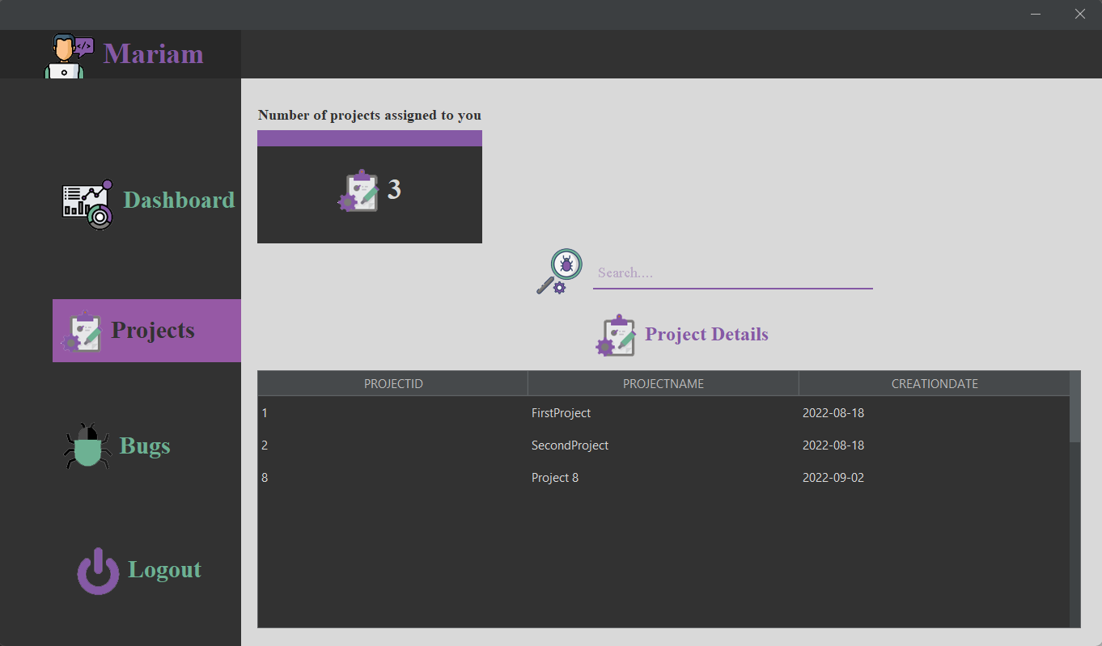

Figure 21 : Tester Page: Project Table

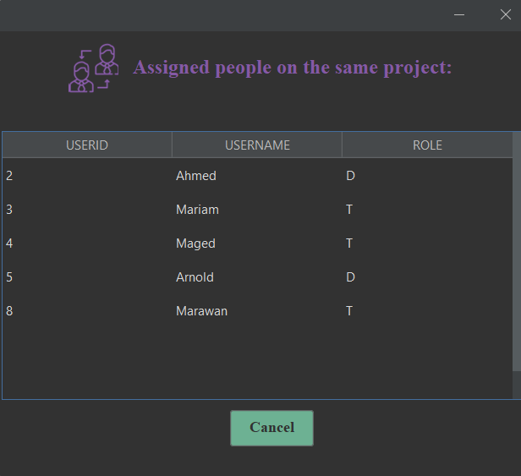

Figure 22:Tester Page: Assigned people to the same project

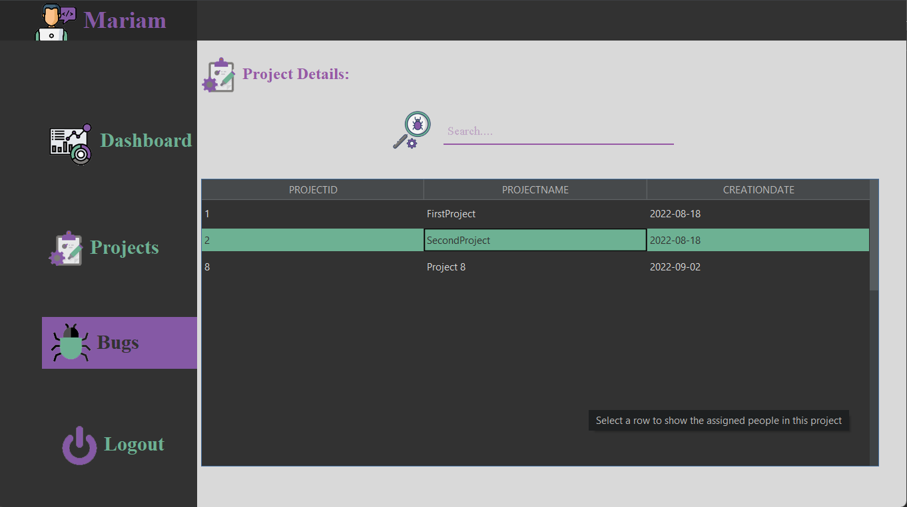

Figure 23:Tester Page: Bugs Panel

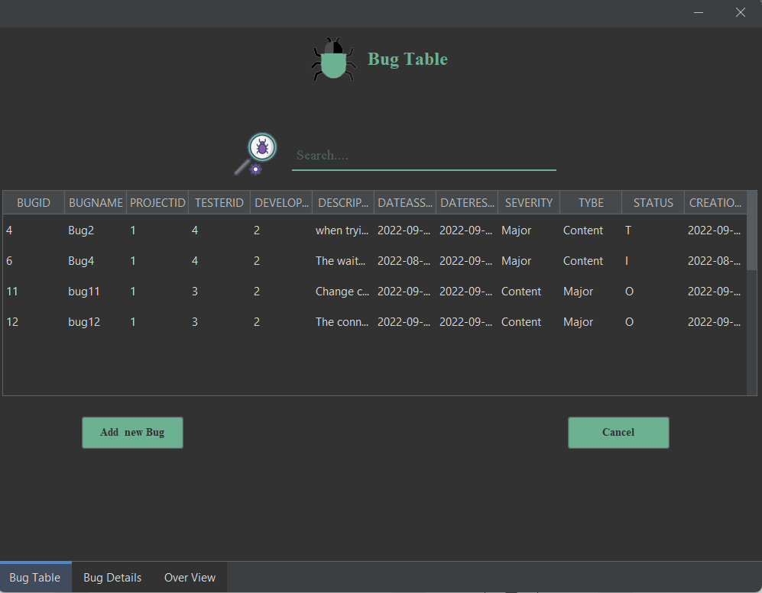

Figure 24:Tester Page: View all the bugs in a specific project

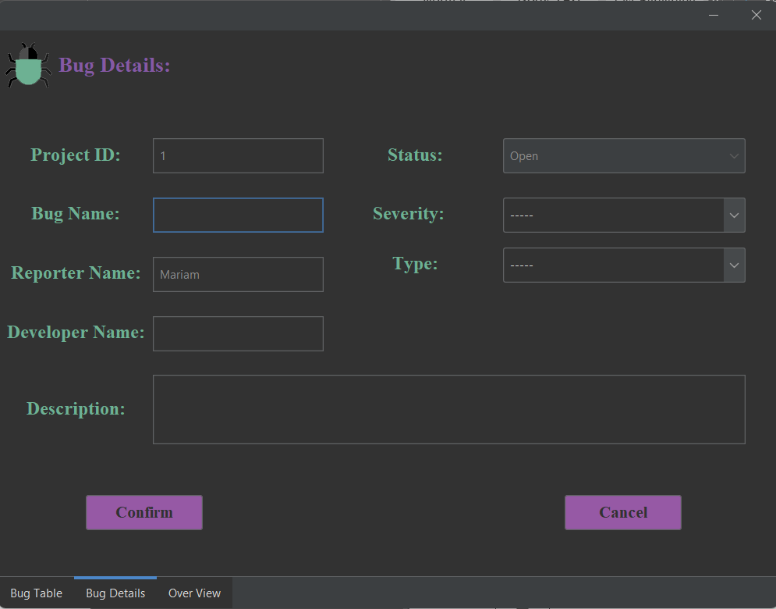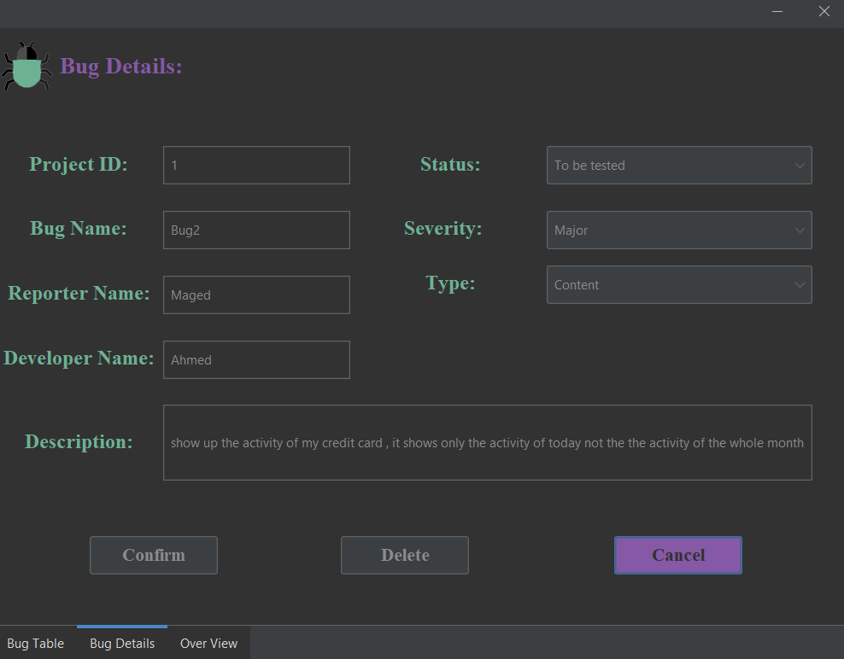

Figure 25:Tester Page: View Bug Details or add new bug

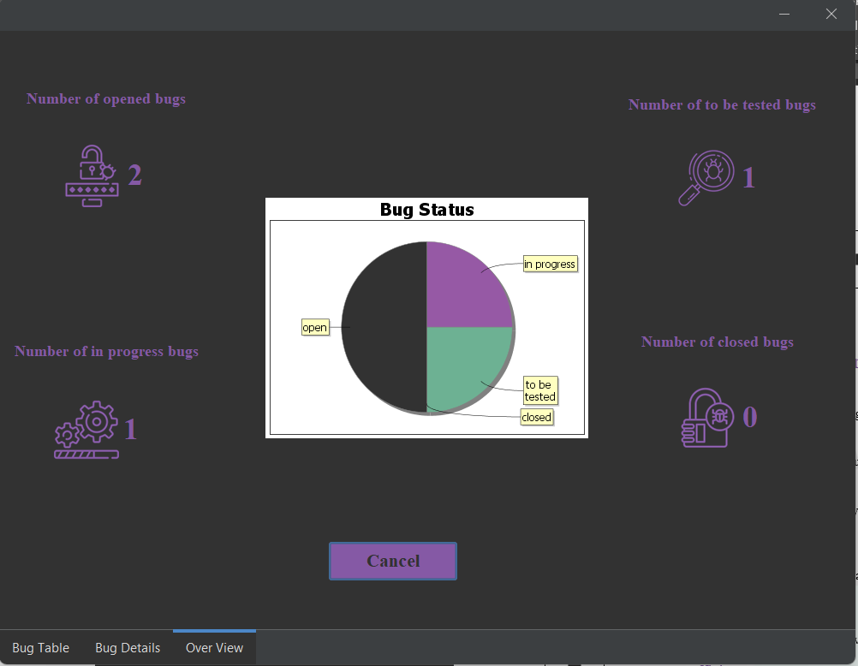

Figure 26:Tester Page: View Overview of Bugs Status

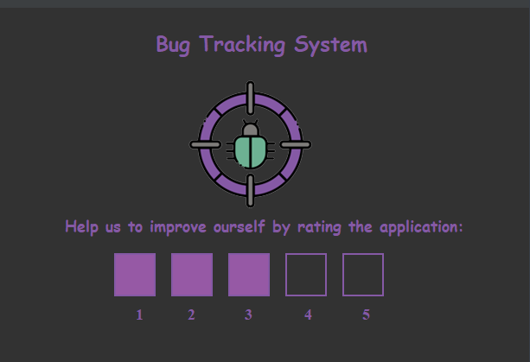

Figure 27:Rating Page

## Software Interfaces:

* Database will be created using apache derby and will be maintained and updated using Git servers.

# Non-functional requirements:

## Availability:

* The system should be available during working hours.

## Security:

* No one can access the system from outside the company.

## Maintainability:

* The system consists of modules every module consists of classes in order, so the system is easy to maintainable.

## Portability:

* The system is a desktop application can run on several operating systems.

## Usability:

* The system is usable for all users (developers & testers).

## Efficiency

* The system is efficient in a lot of software companies because it solves the bugs of the software.

# System Models and Diagrams:

* Context diagram:

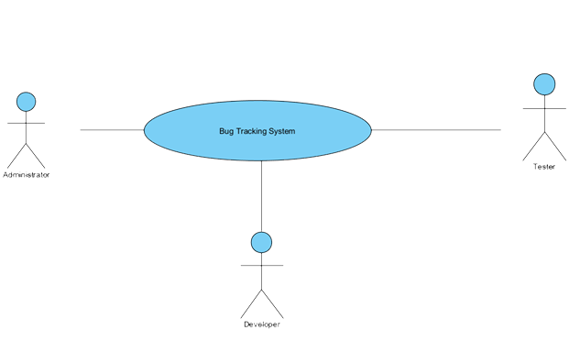

Figure 28:context diagram

* Class diagram:

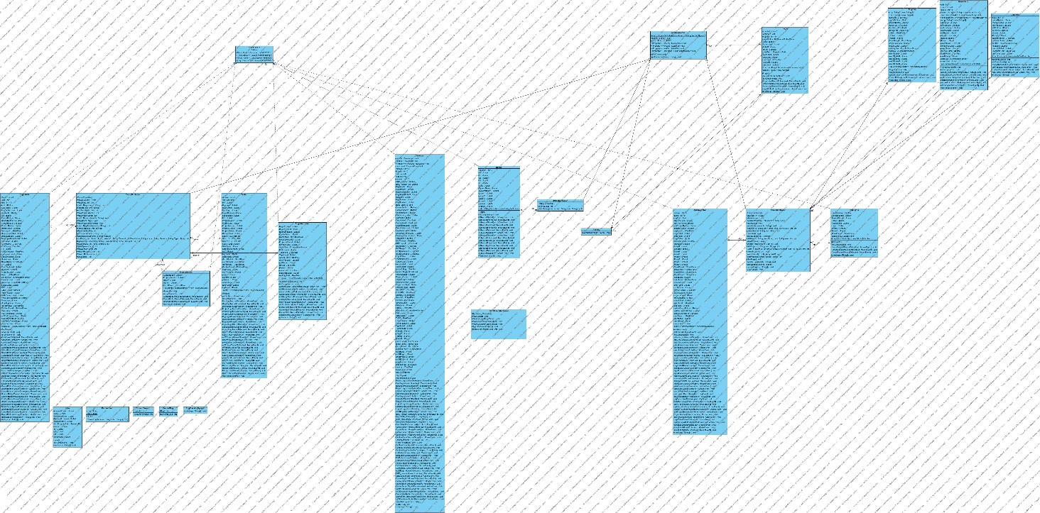

Figure 29 : Class diagram

* Use case diagram:

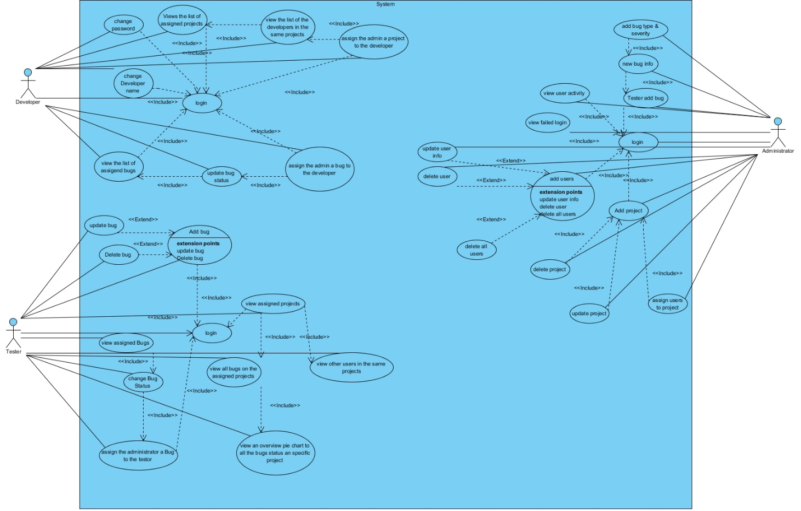

Figure 30 : Use case diagram

* Sequence diagrams:
* **Administrator:**

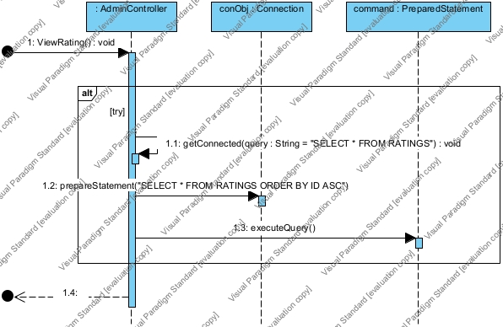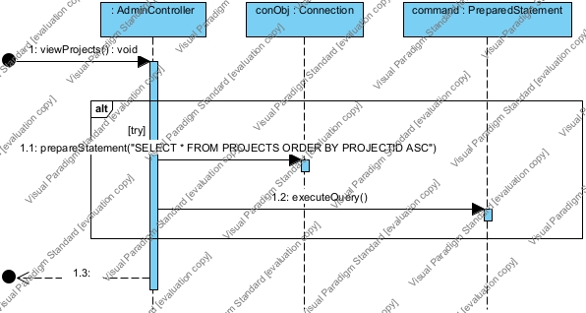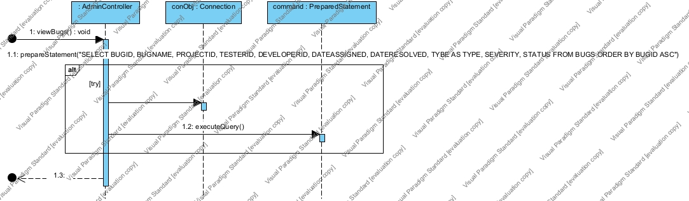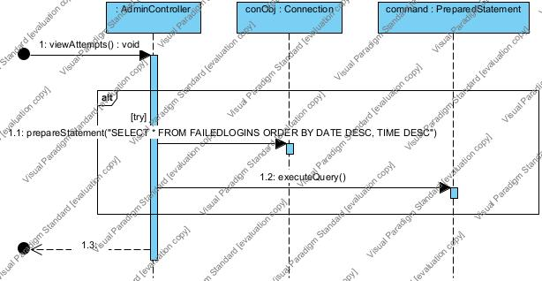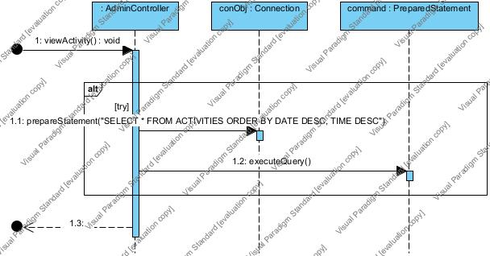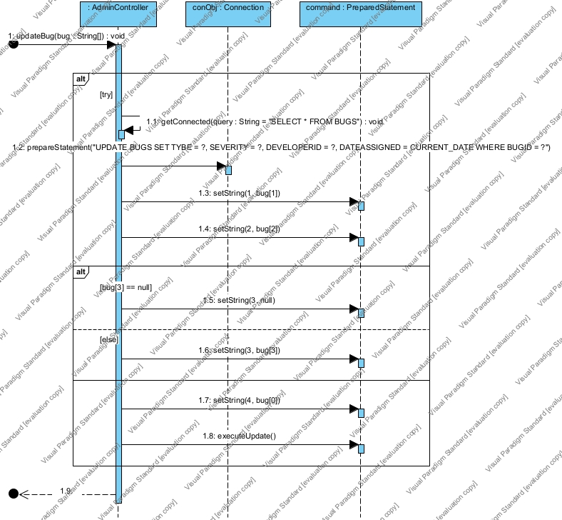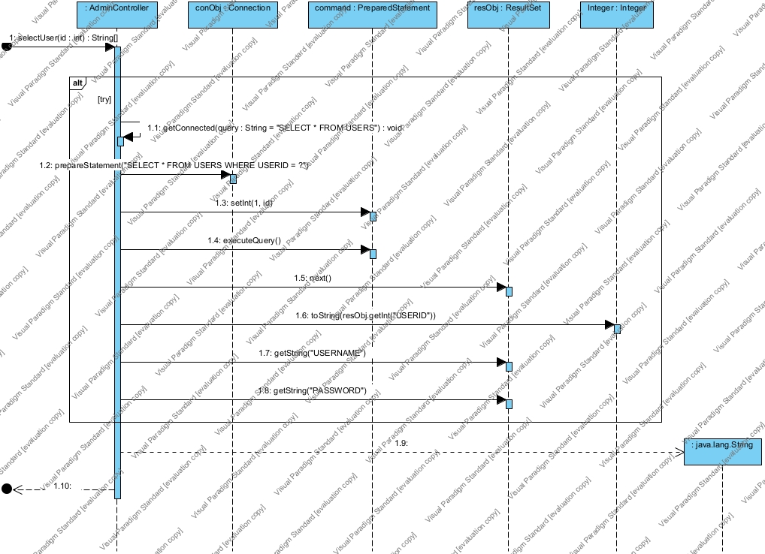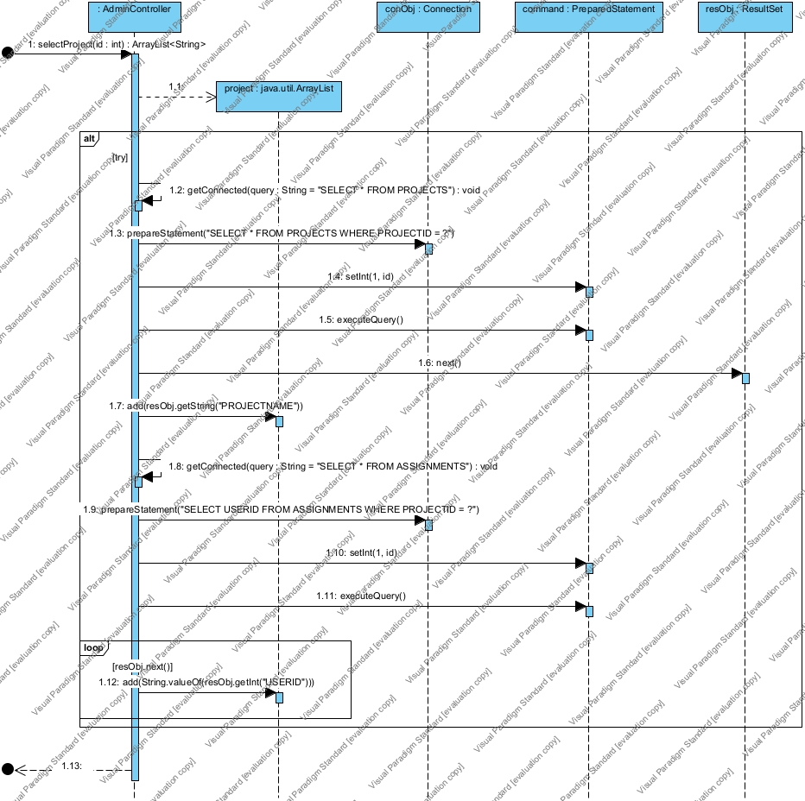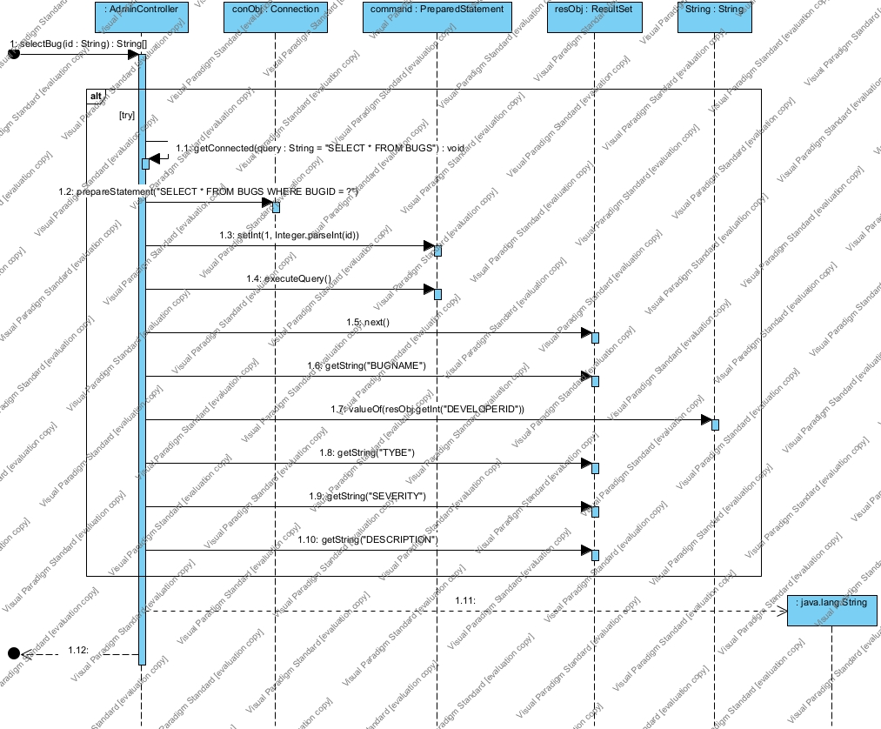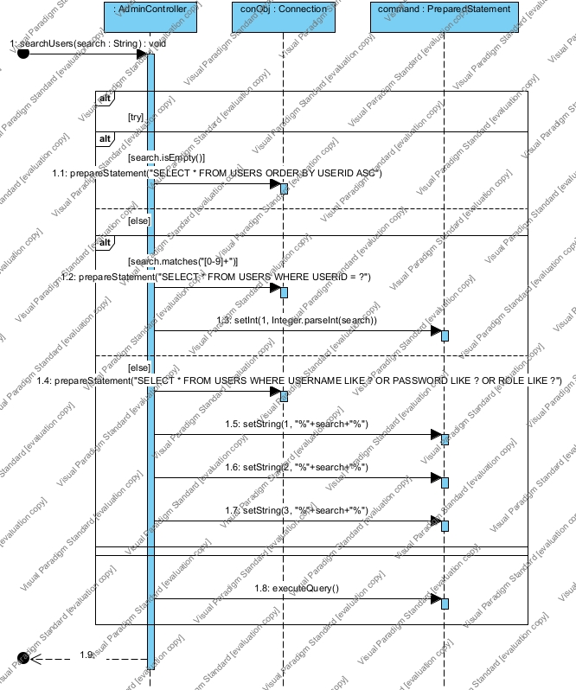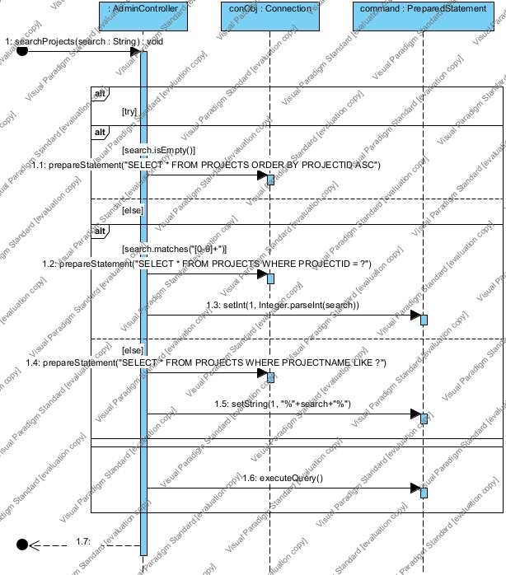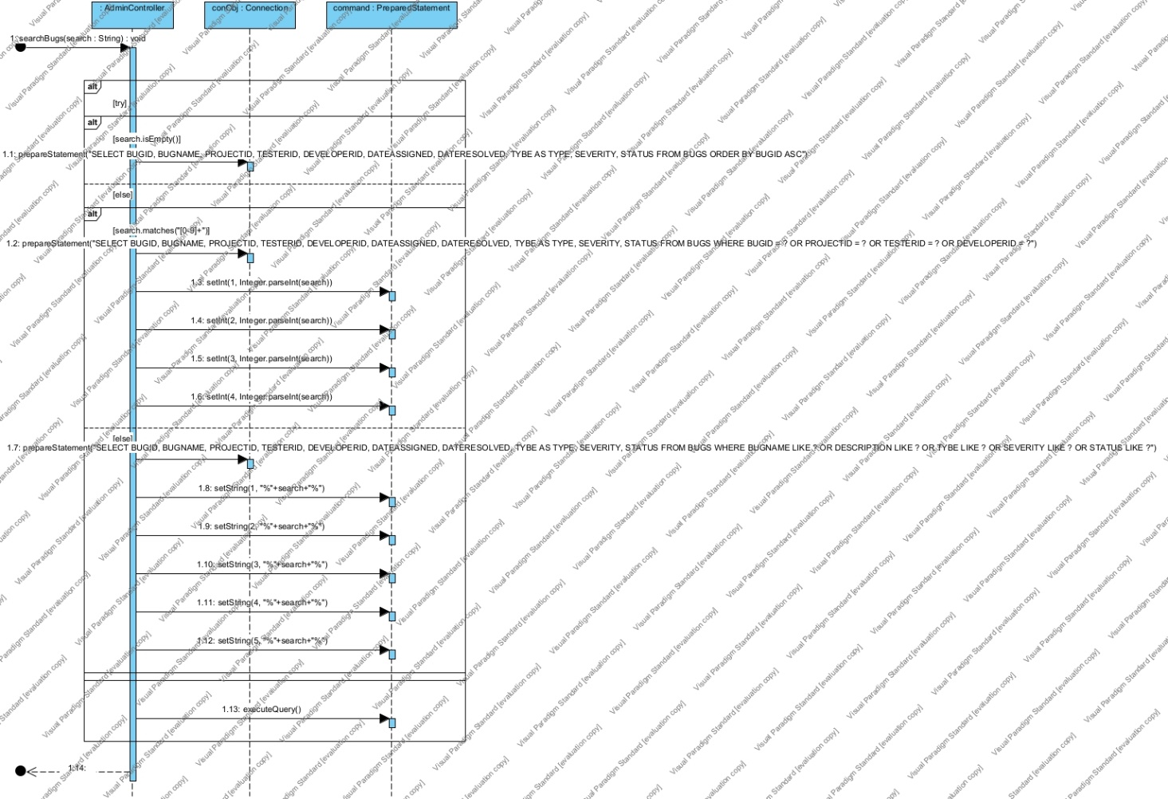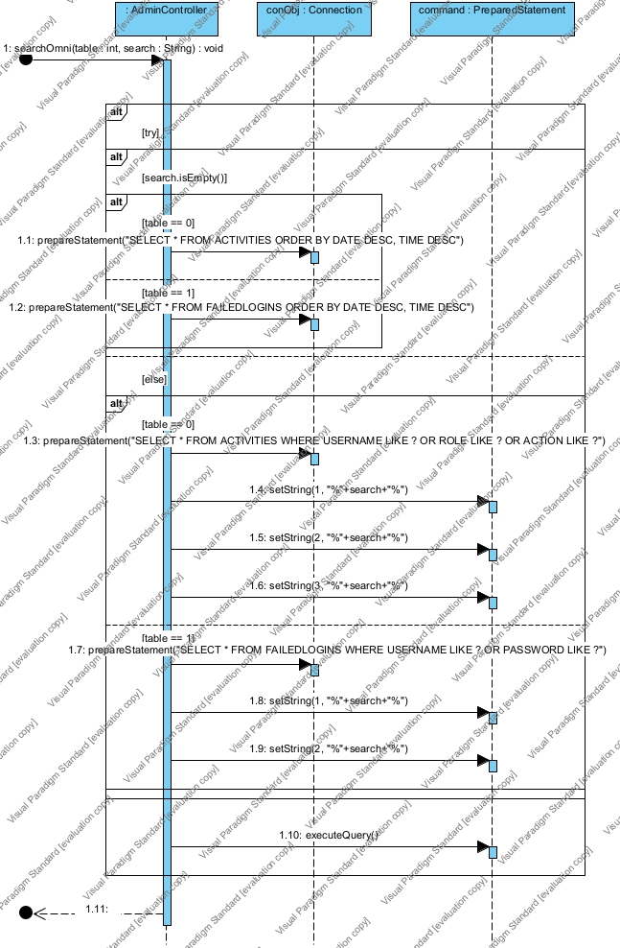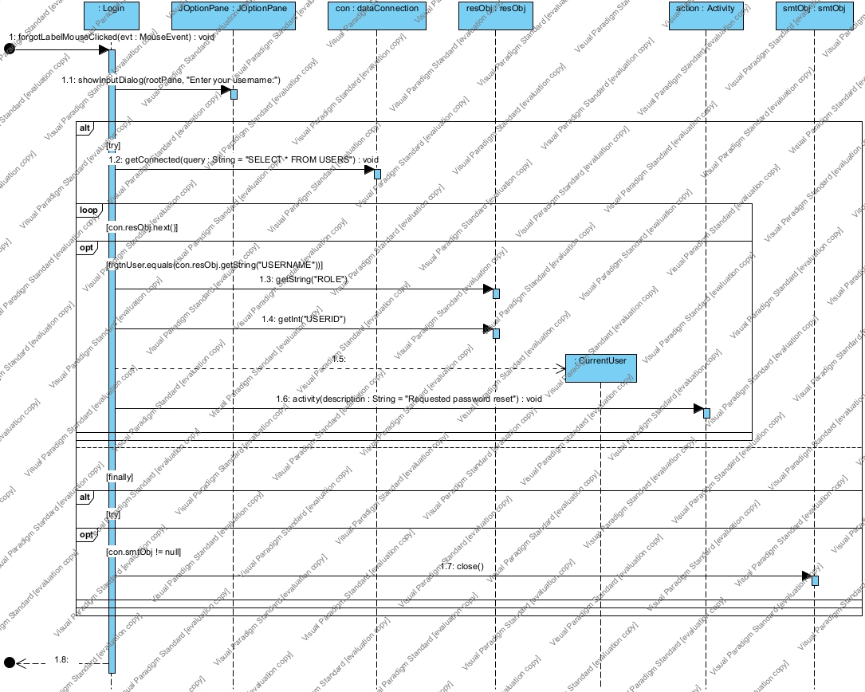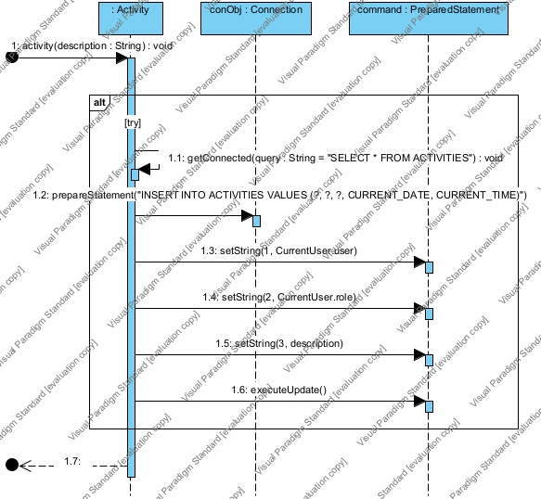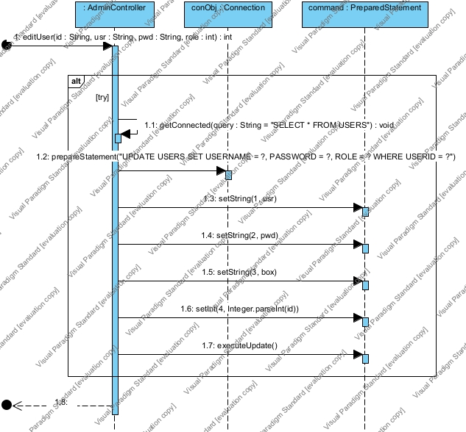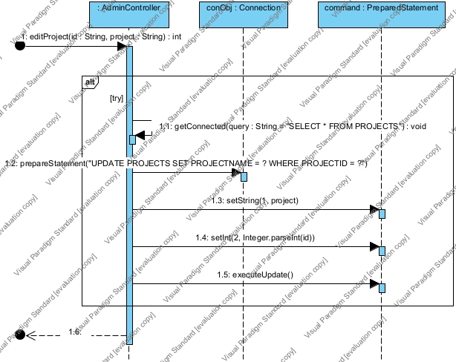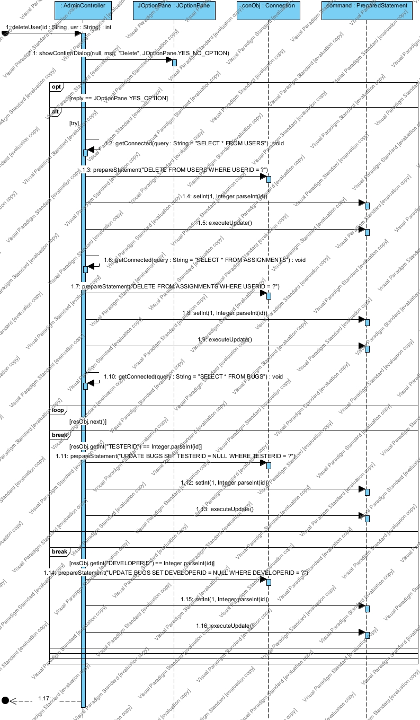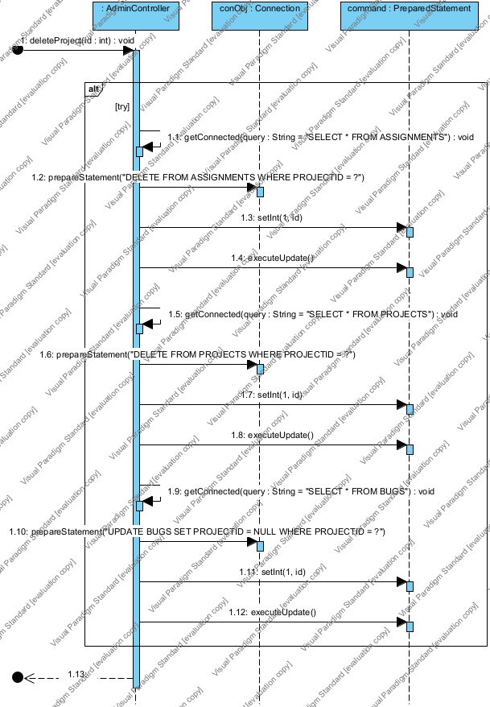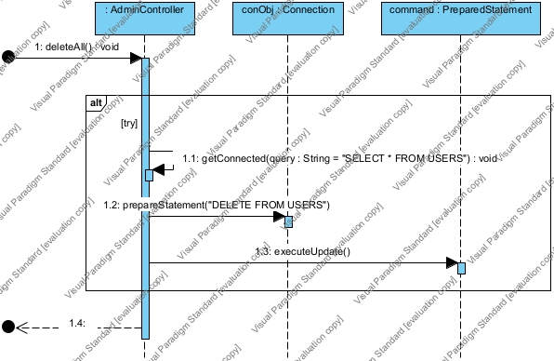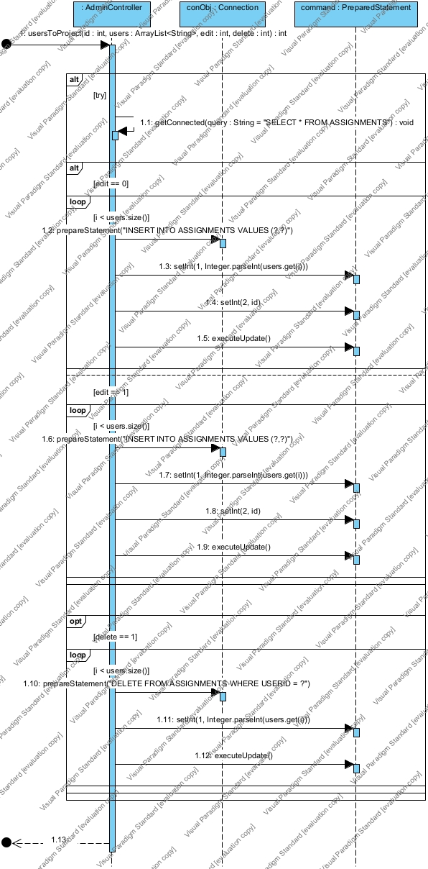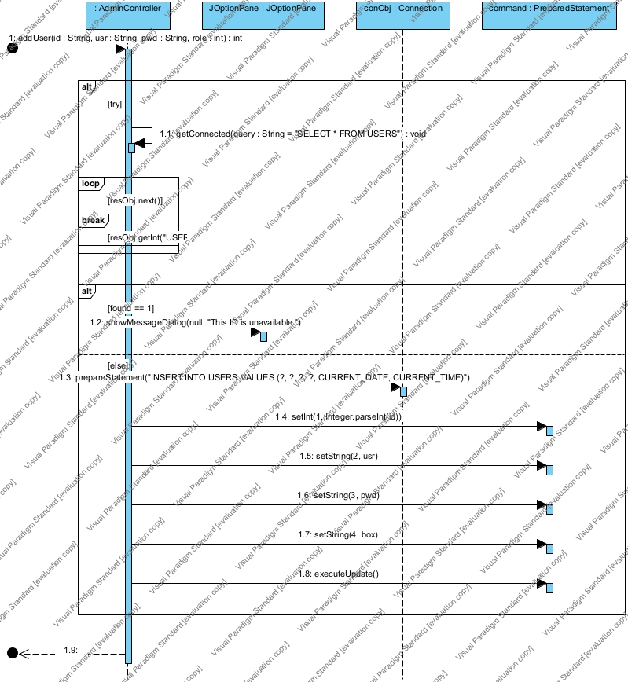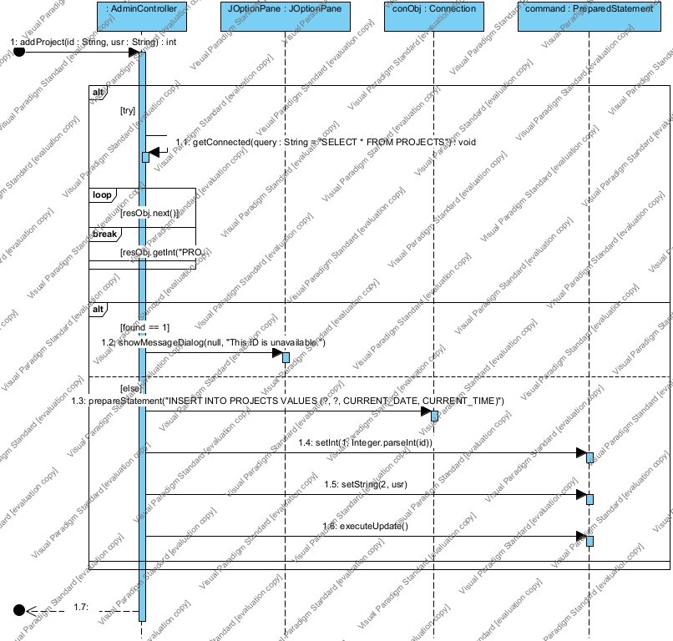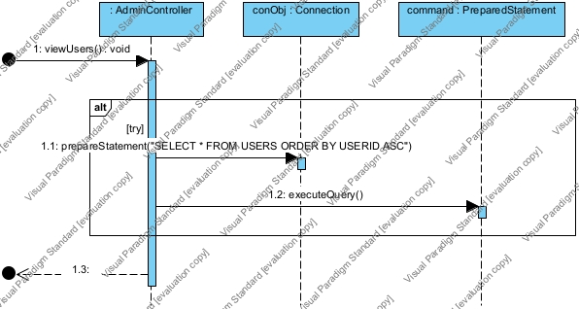

* **Tester:**

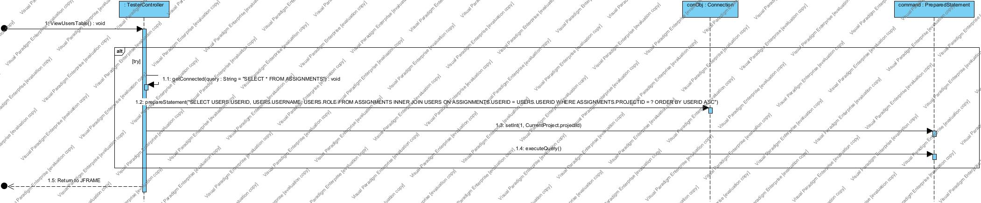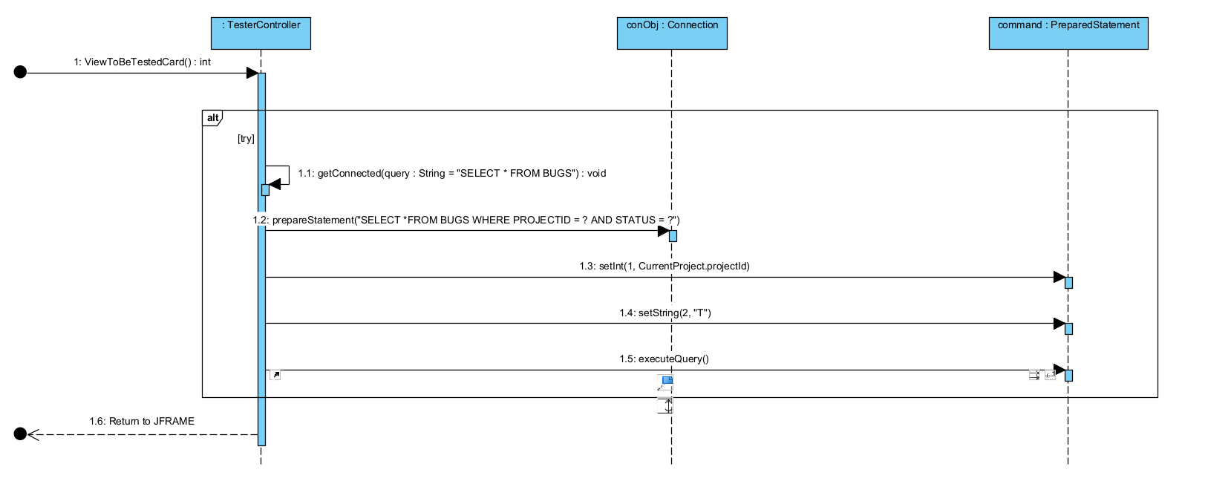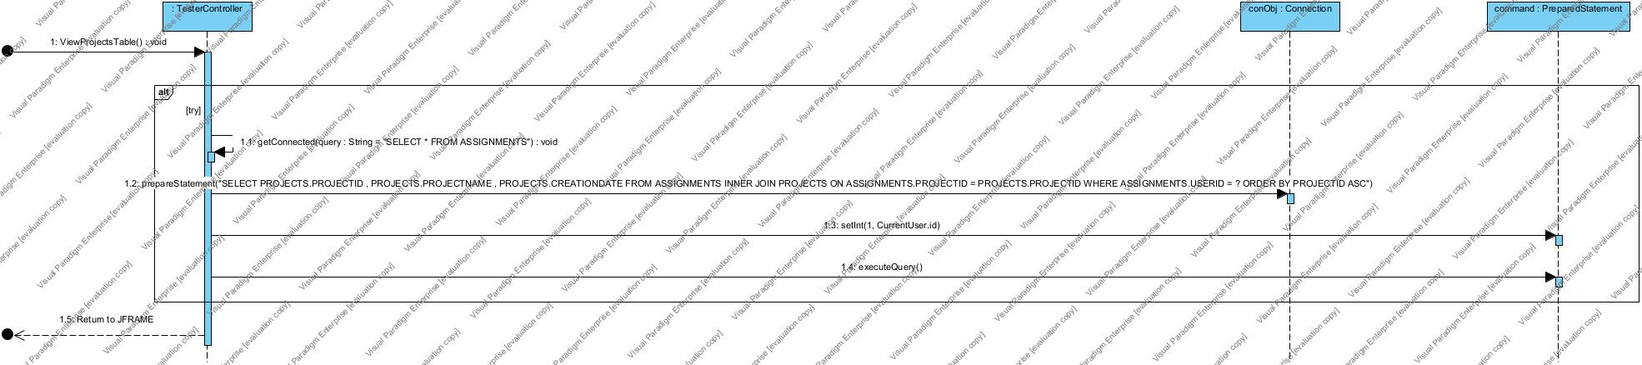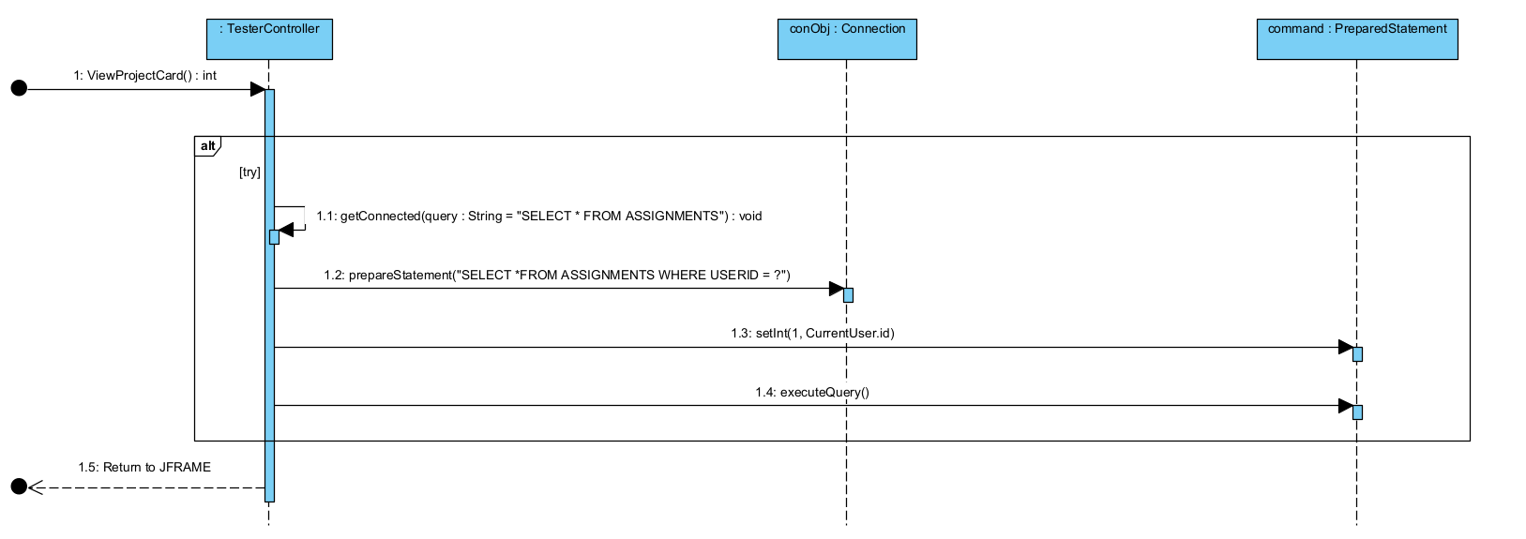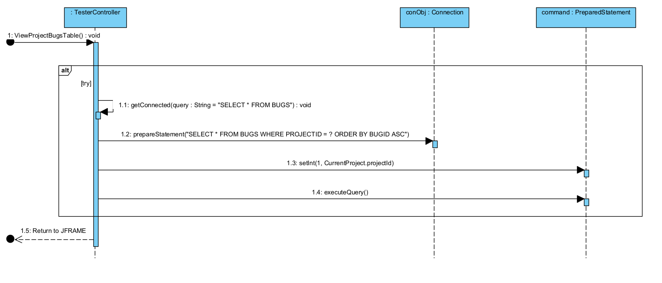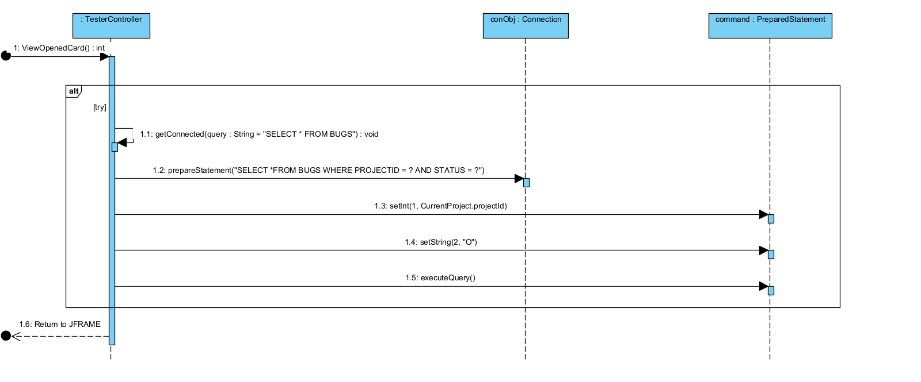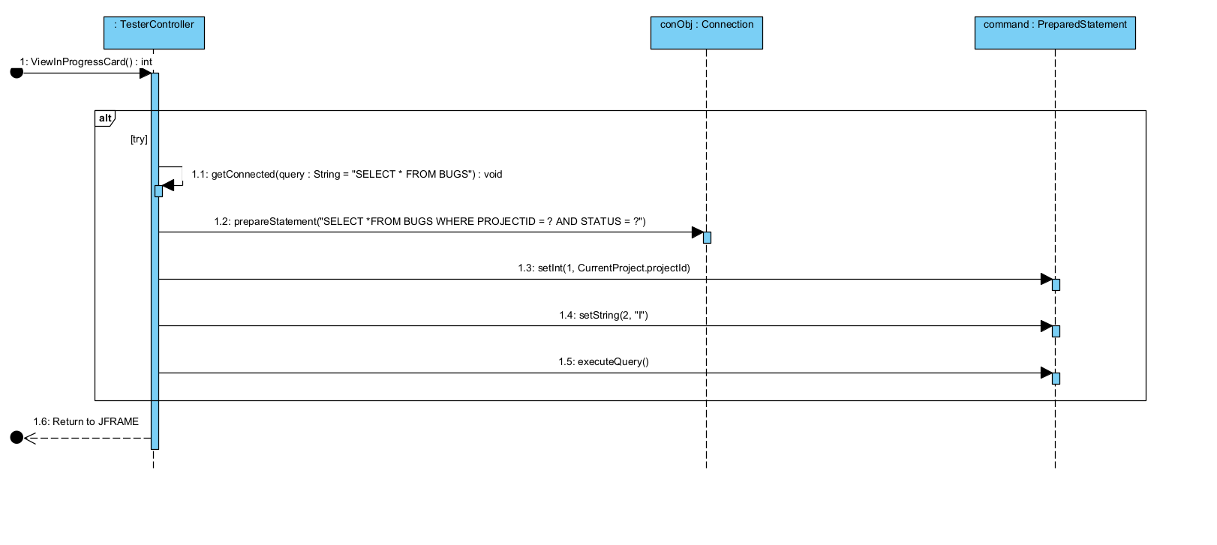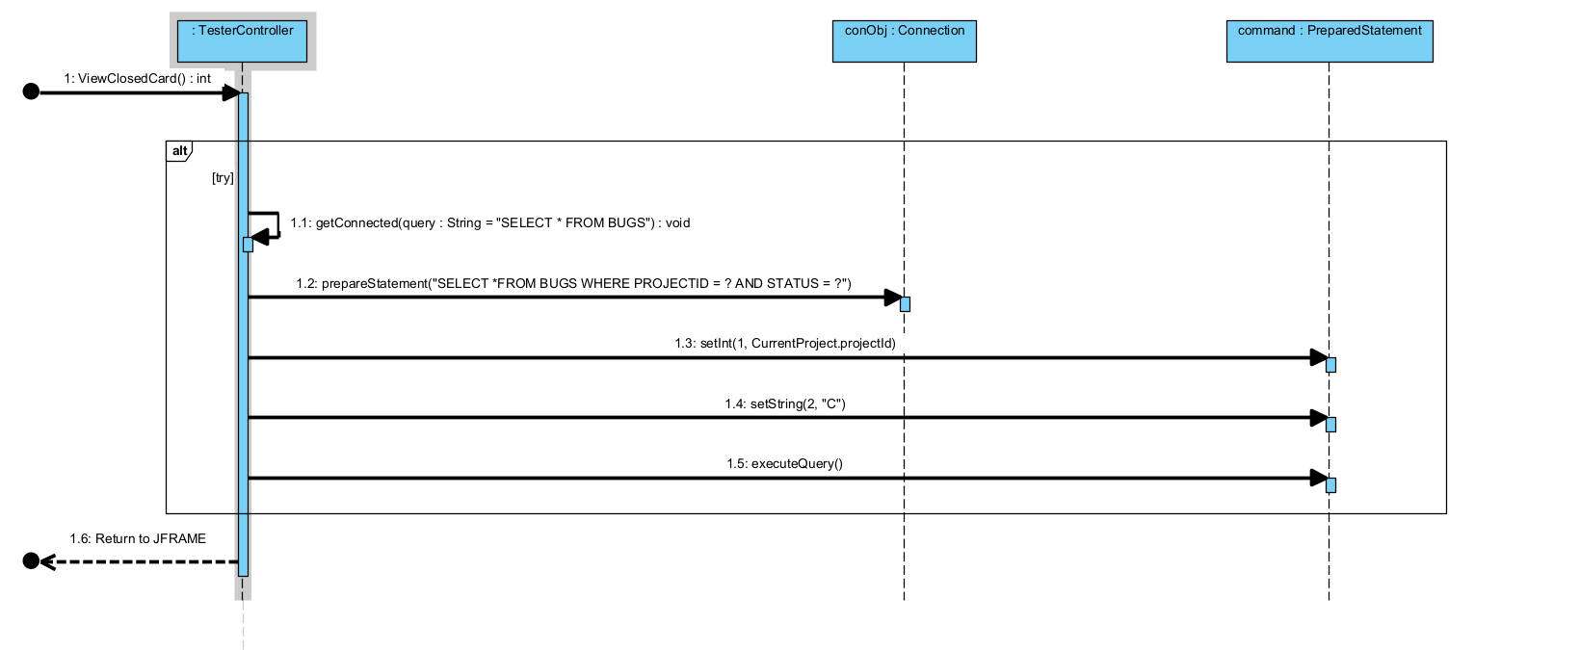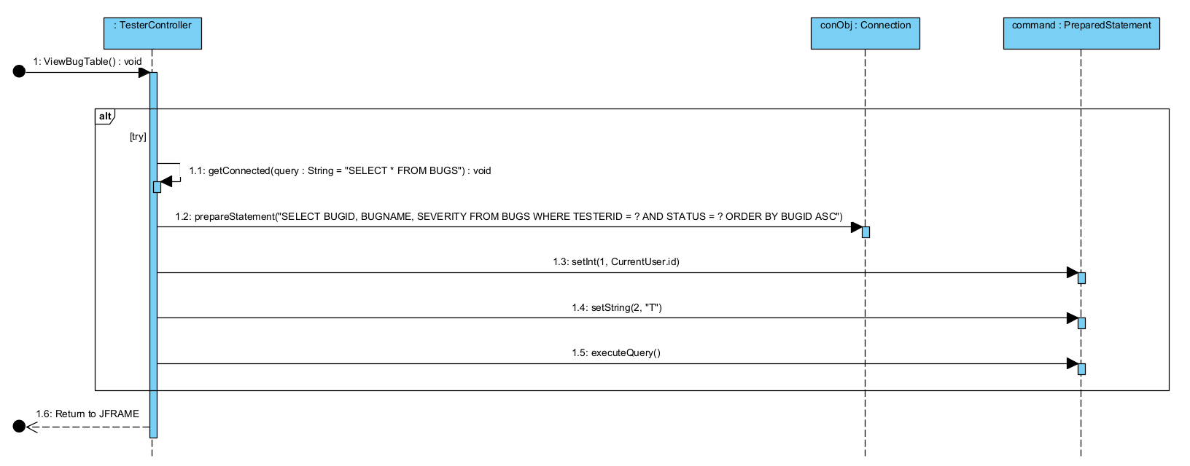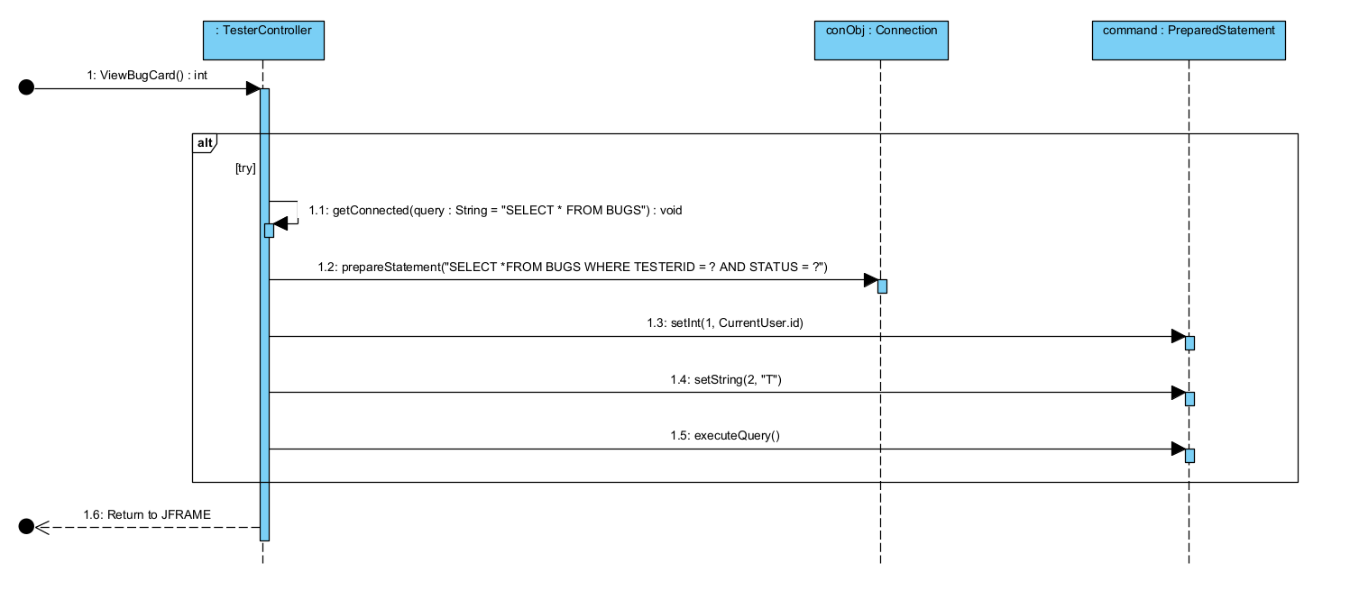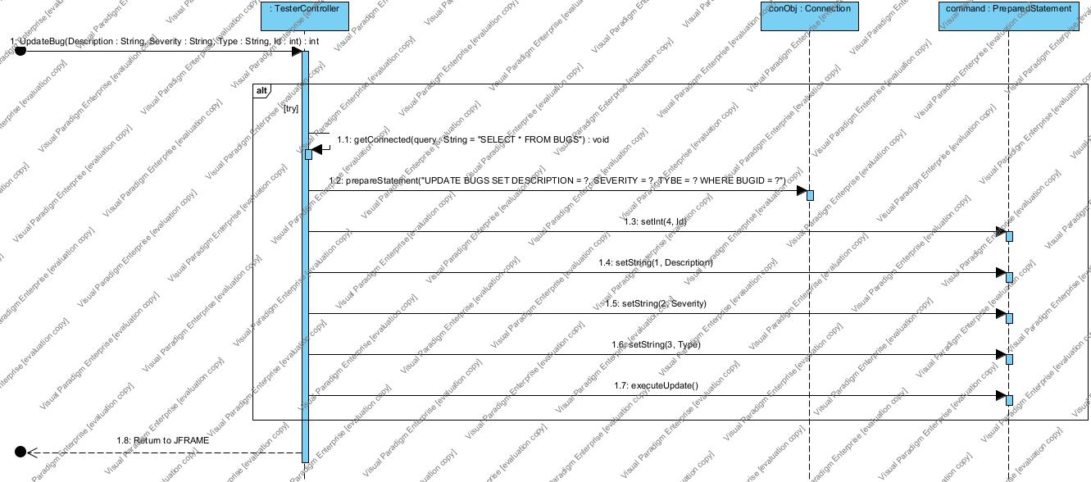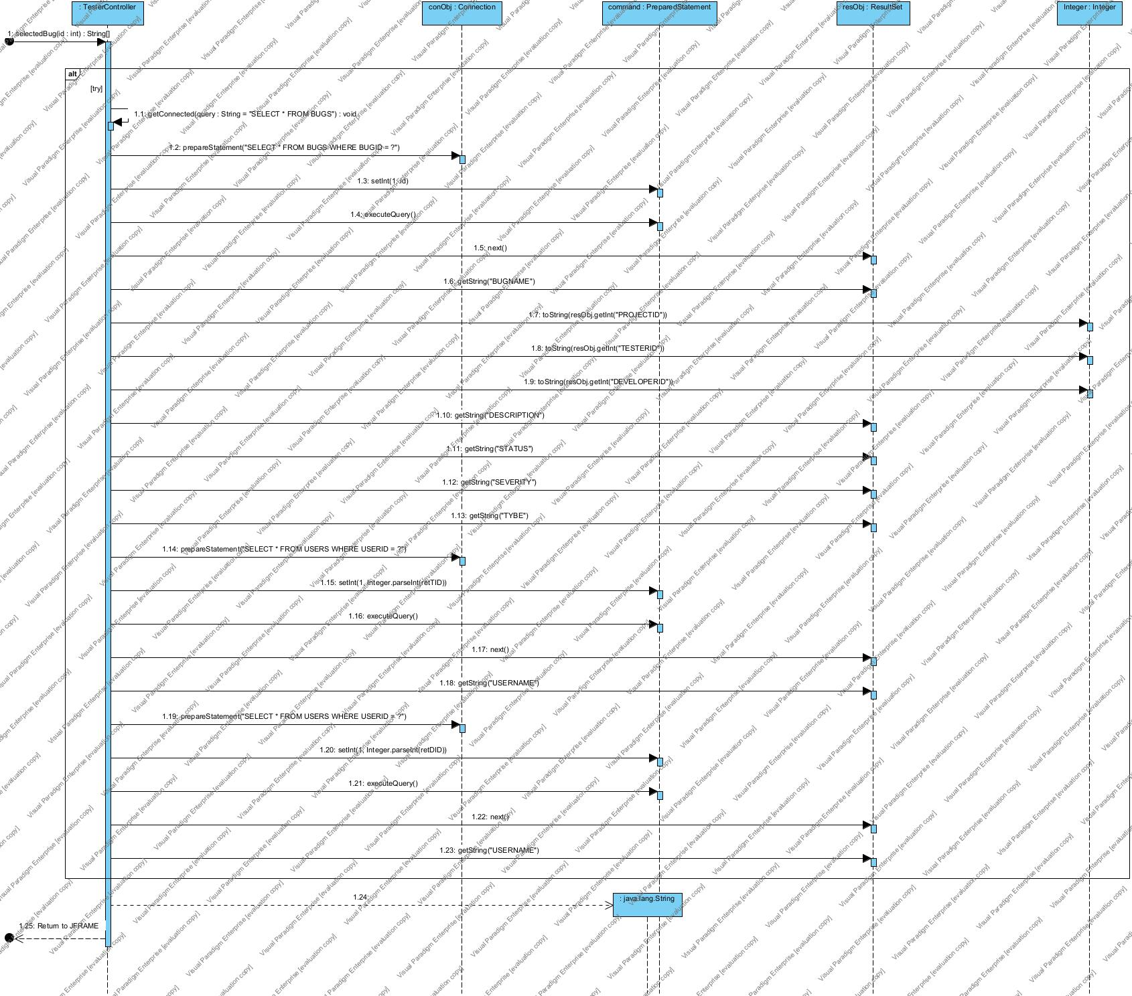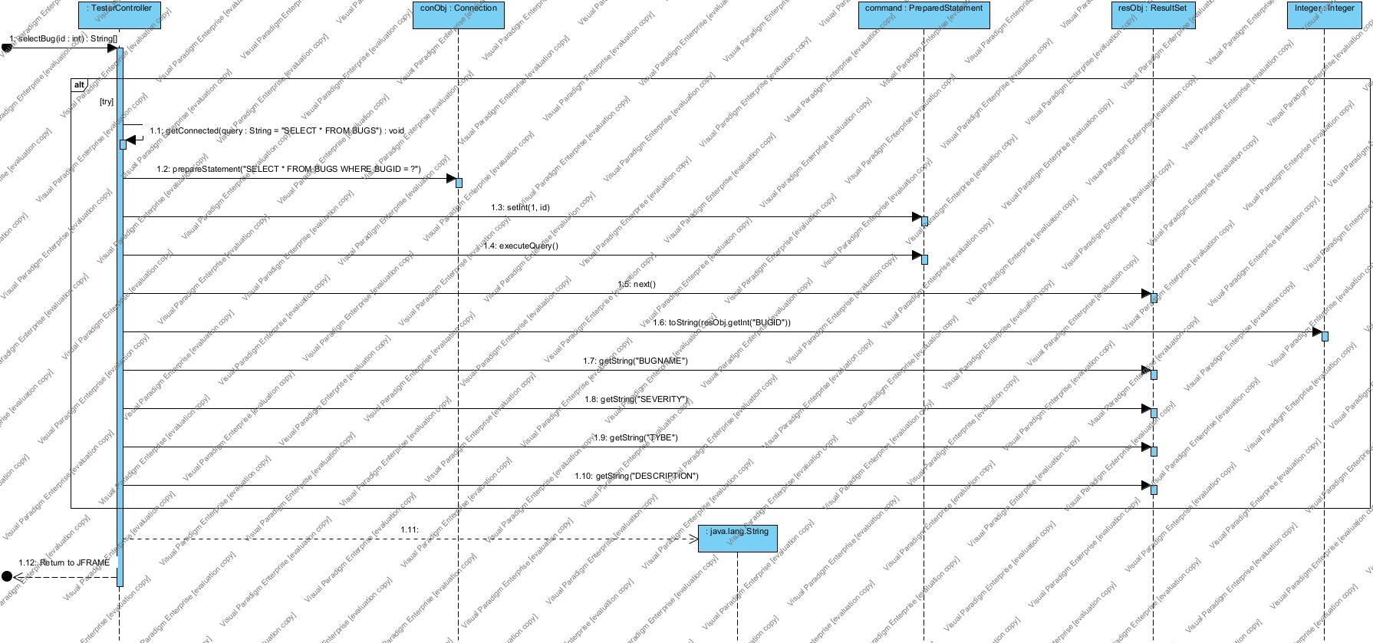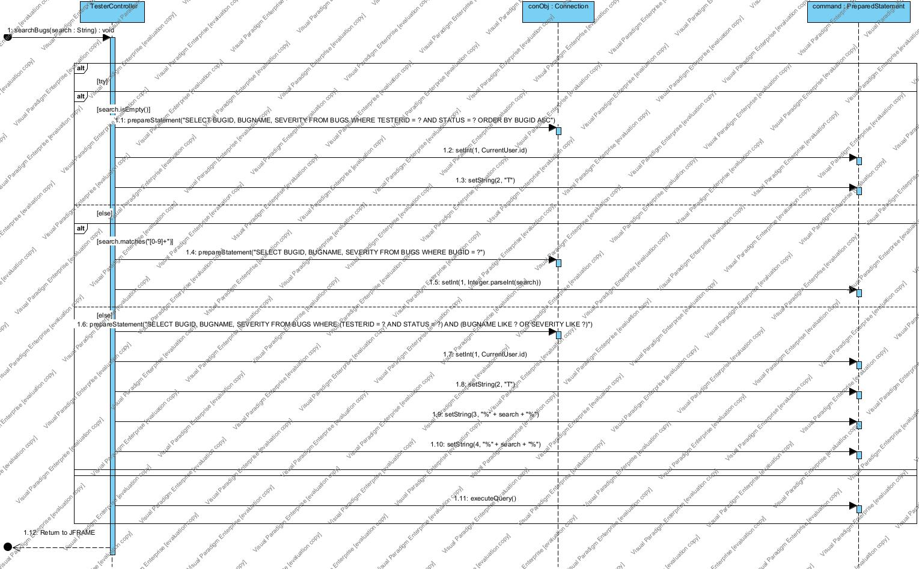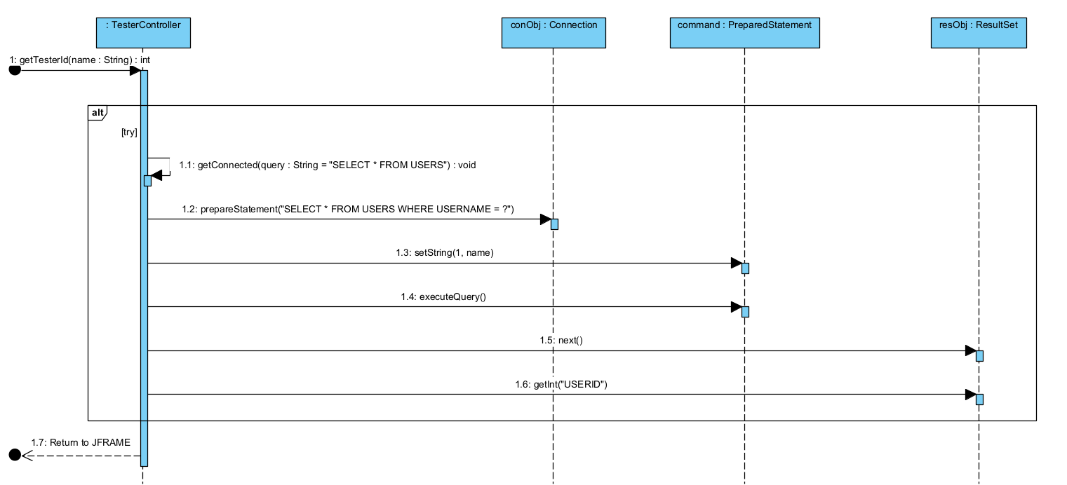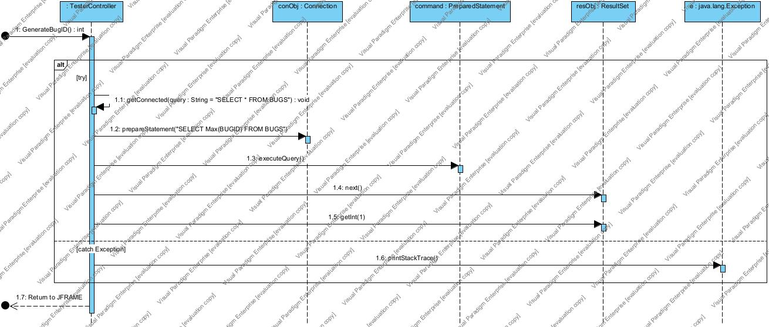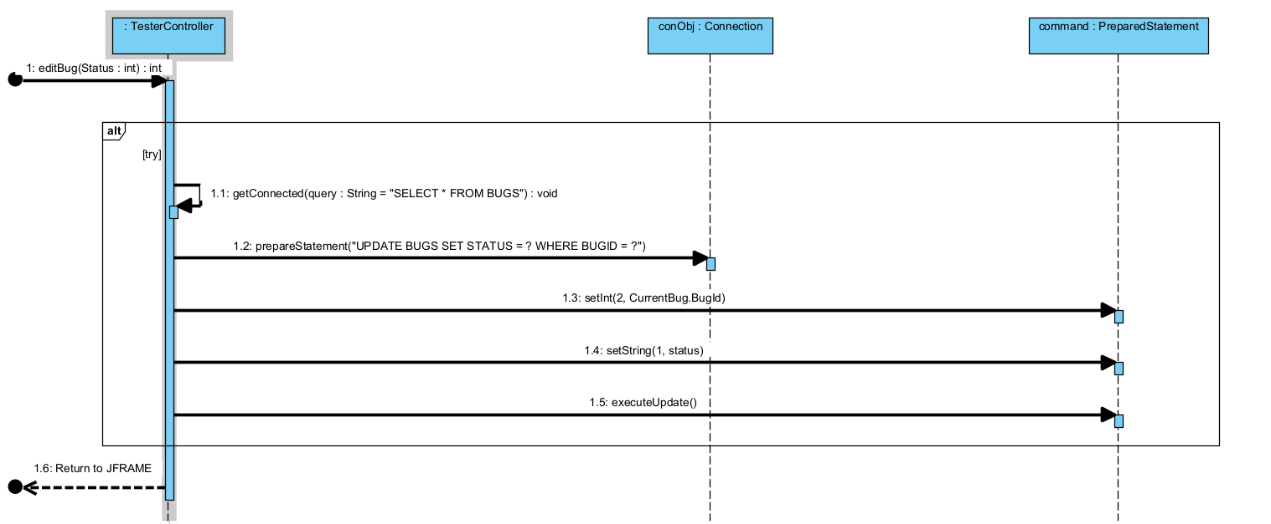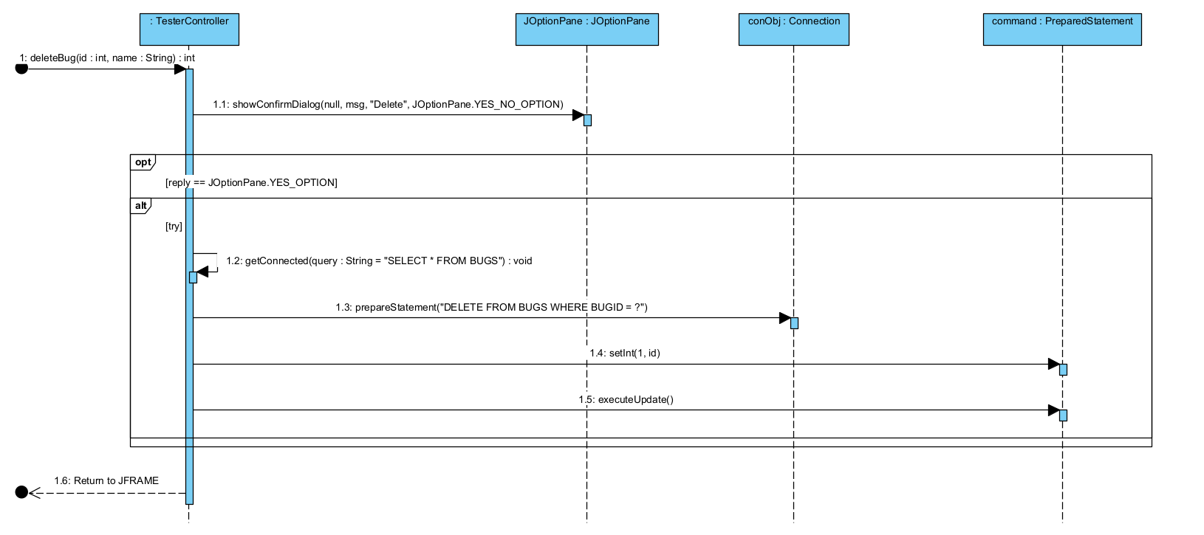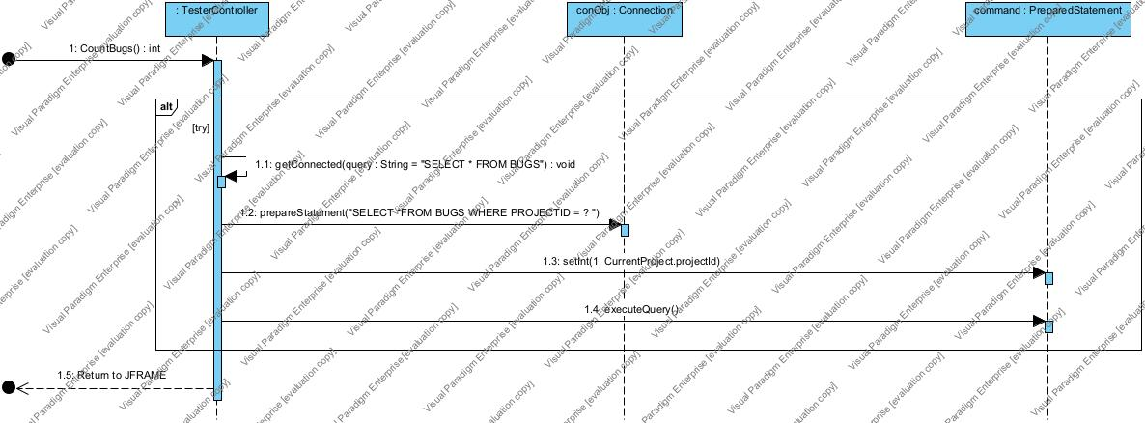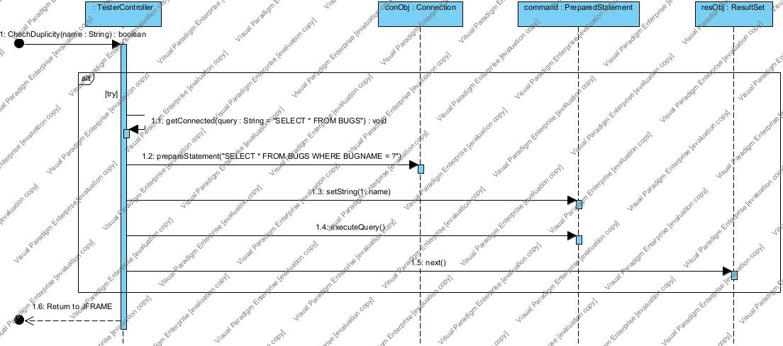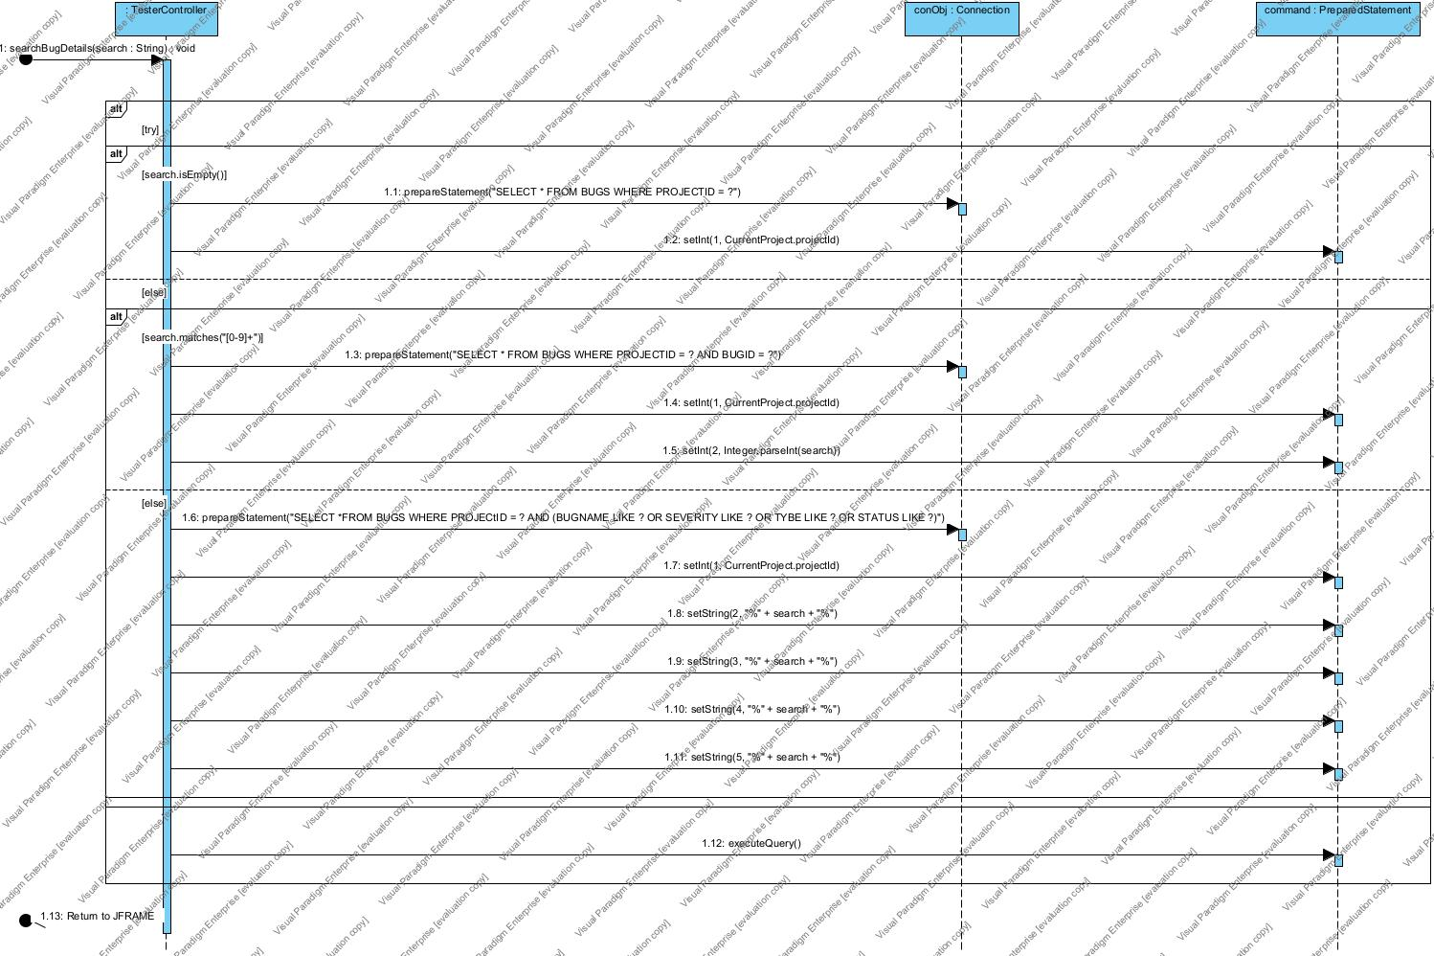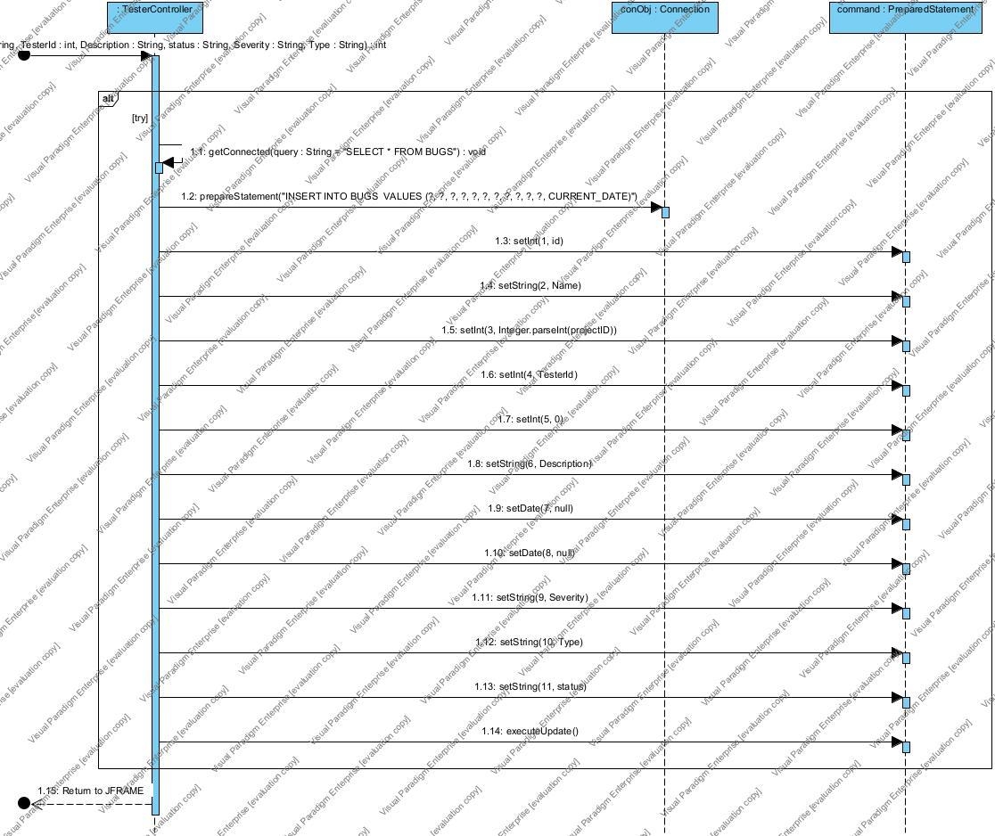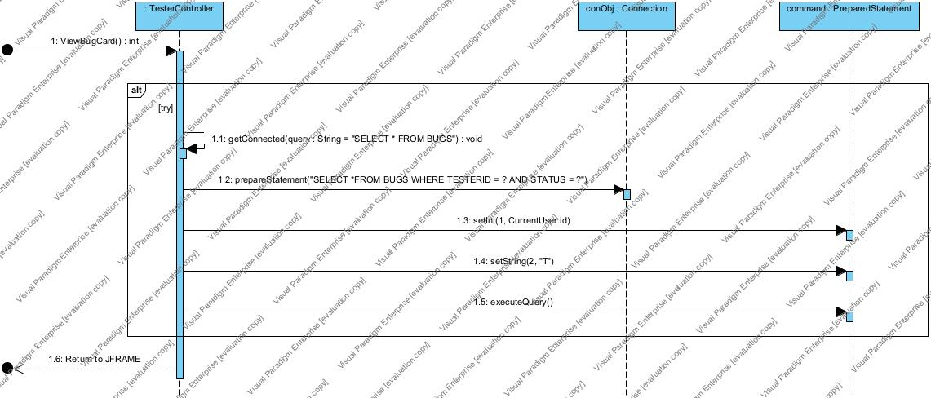

* **Developer:**

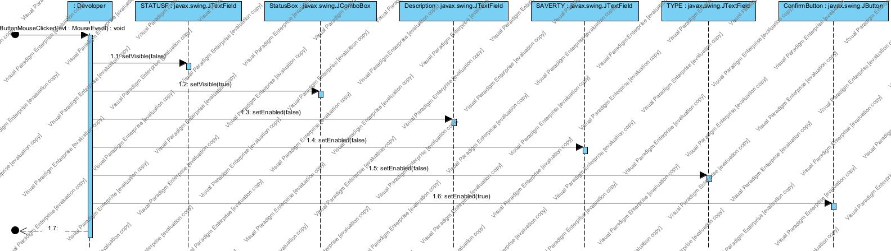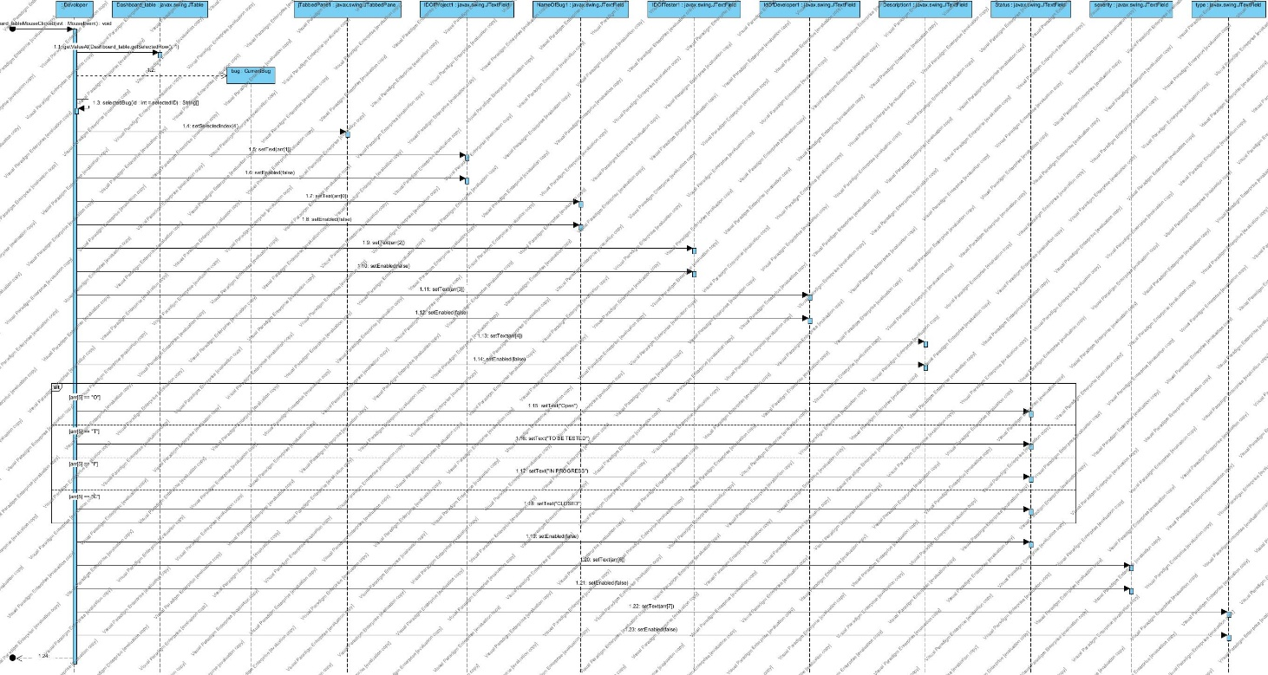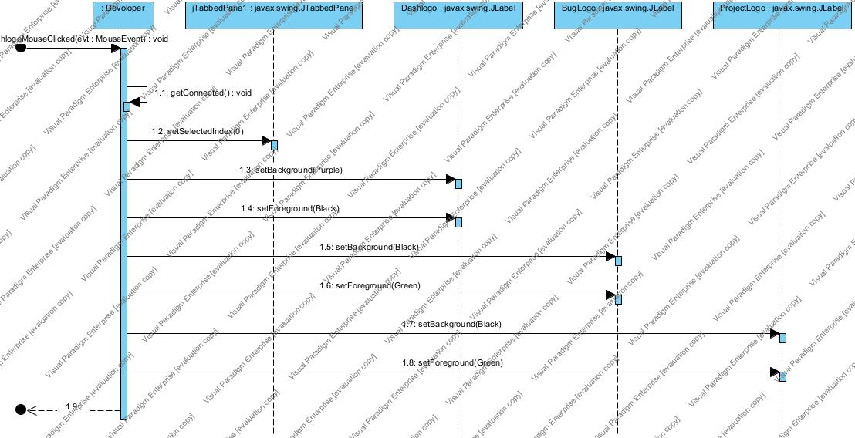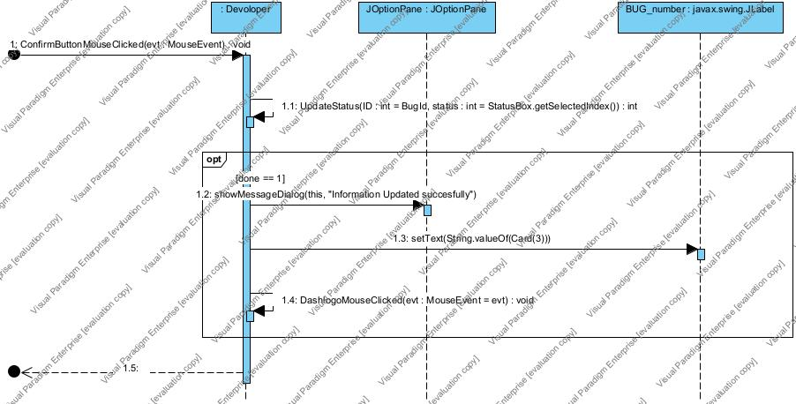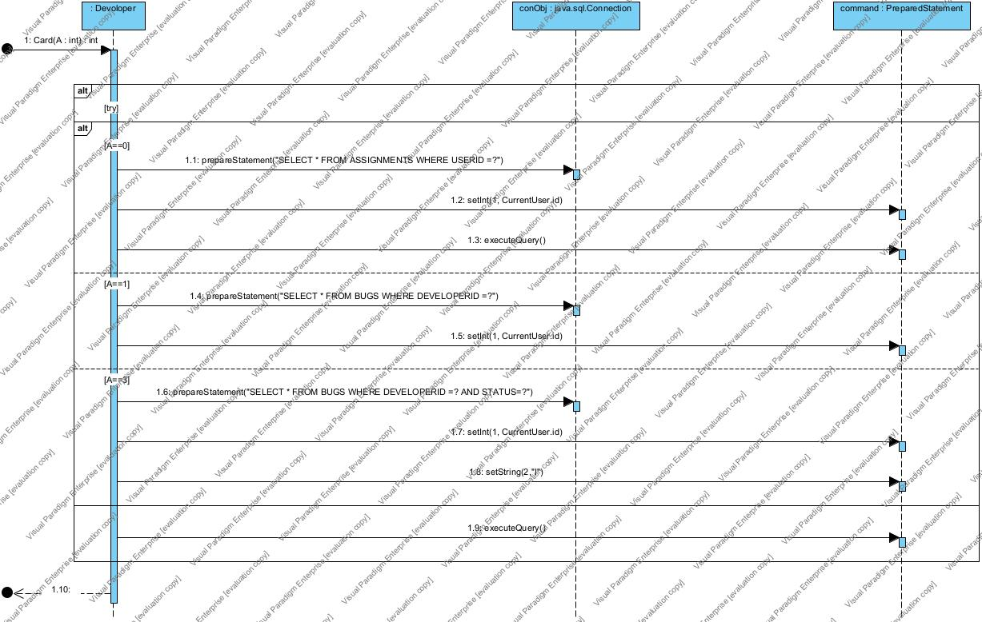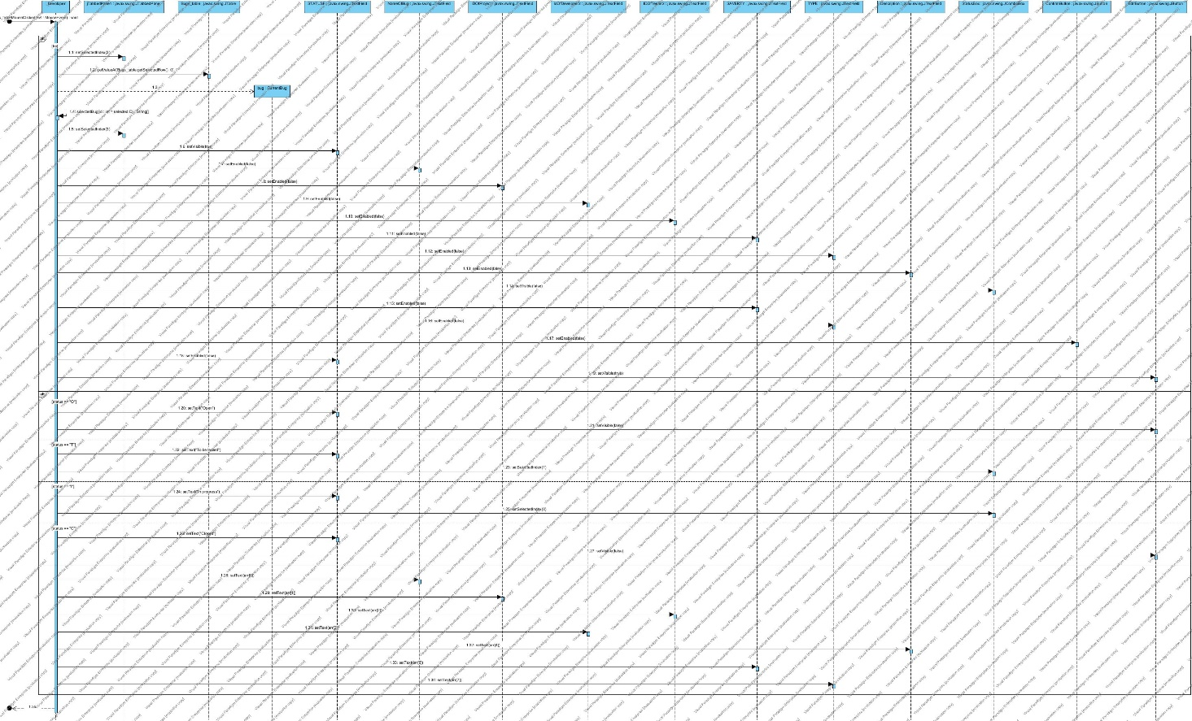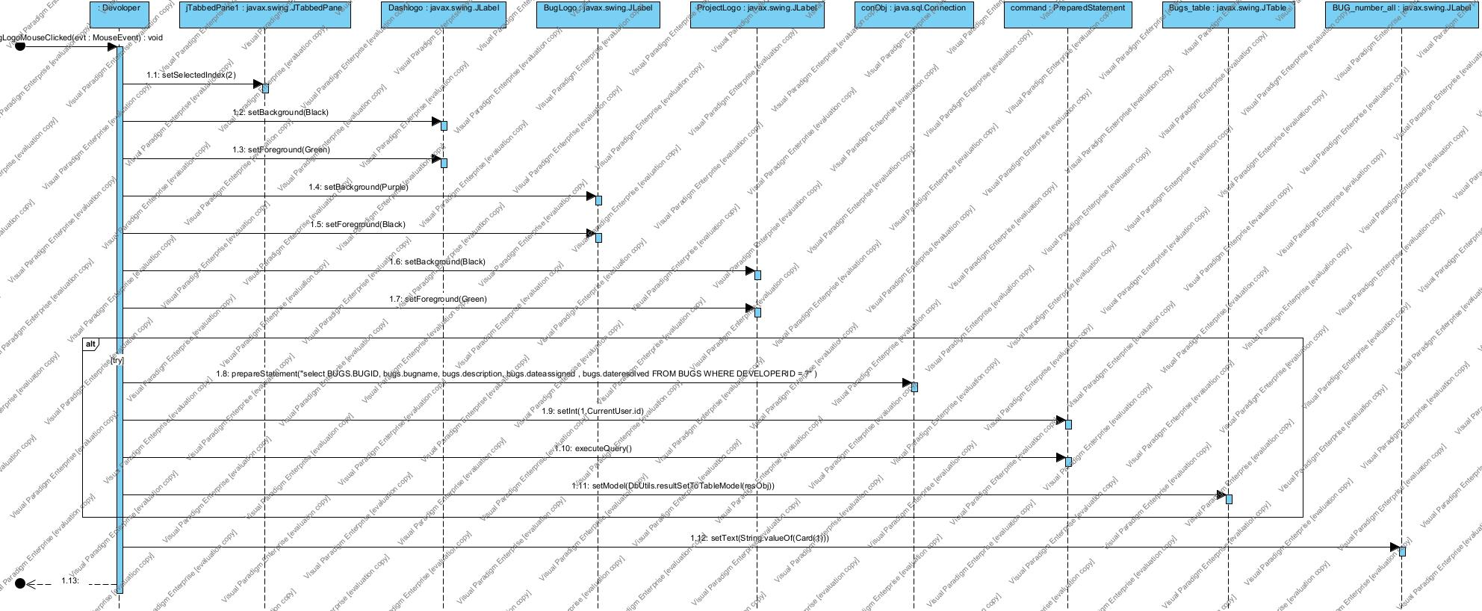

* **System diagrams:**

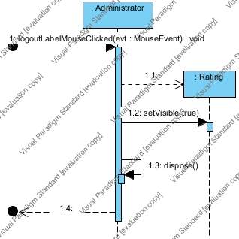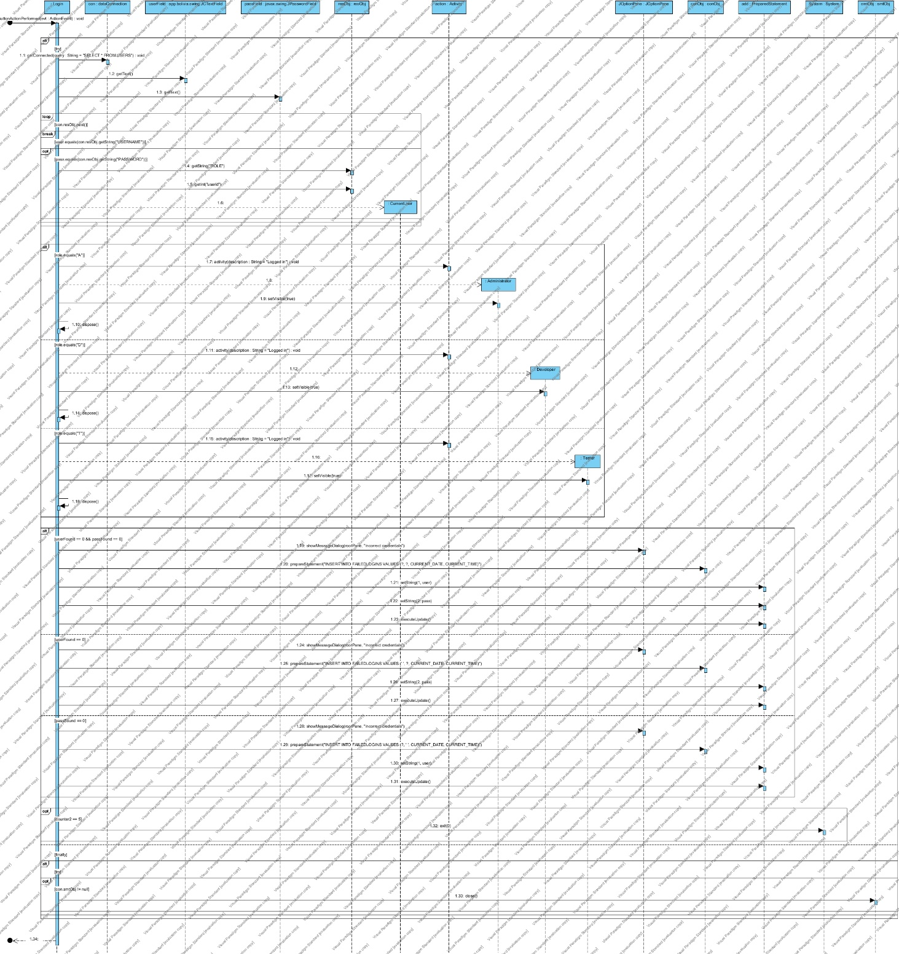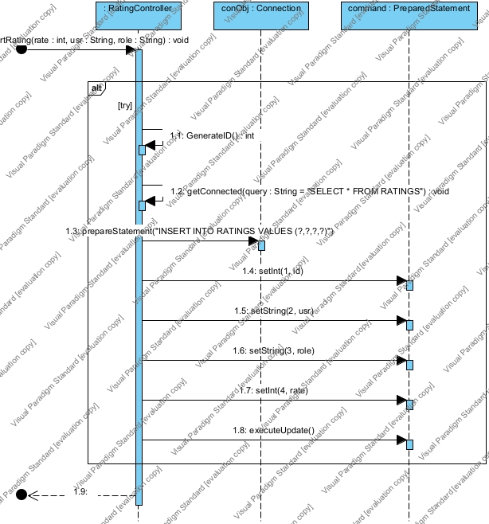

# System Evolution:

* The system should be able to work on different operating systems.
* It should work properly on devices with low specifications. Only the server on which it’s installed will be powerful.

# Future Work:

* Turn the project from a specific use for bugs tracking into general use for project tracking.
* Administrator:
* Print users data in a table.
* Print entire project’s bug information.
* Print information about each bug in the project individually.
* Tester:
* Print information about each bug in the project individually.
* Enhance the communication between testers and developers by adding comments in each project.
* Developer:
* Add errors and request assistance.
* Print information about each bug in the project individually.
* Enhance the communication between testers and developers by adding comments in each project.

# Time Plan:

## Work Breakdown Structure:

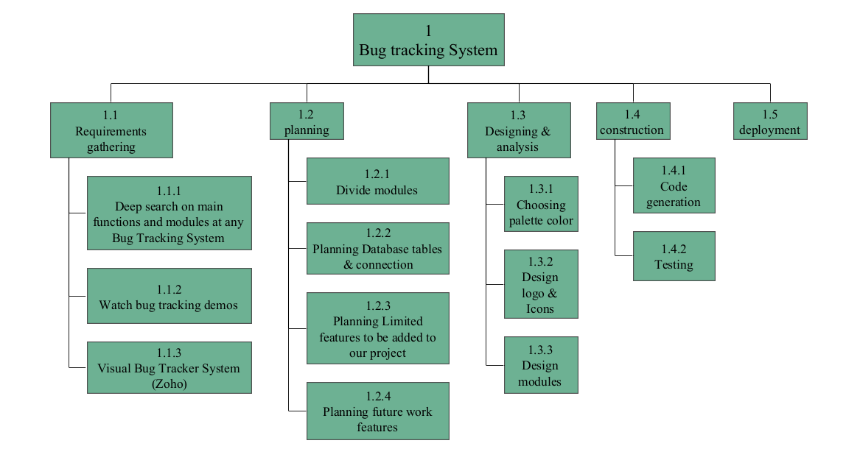

Figure 31 : Work Break Down Structure

## Gantt chart:

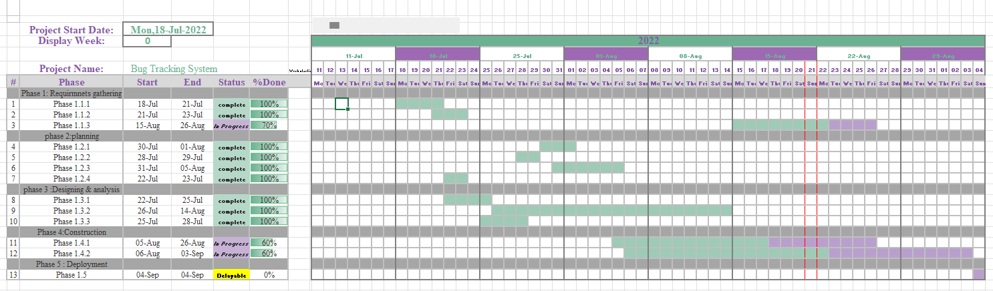

Figure 32 : Gannt chart

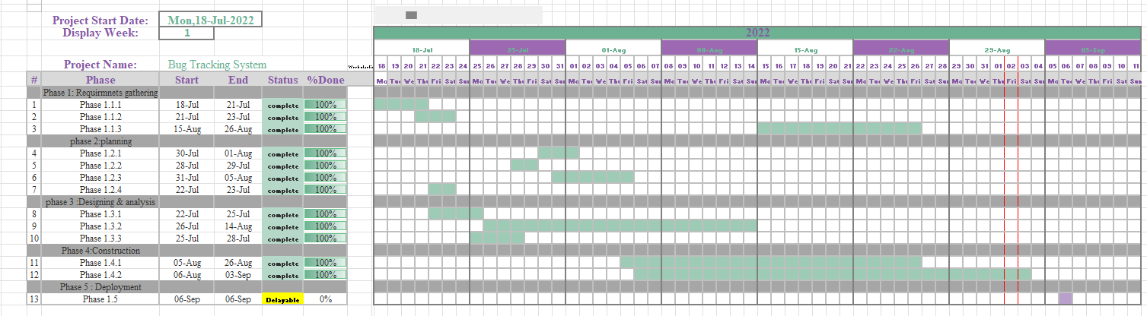

Figure 33 : Updated Gantt Chart

# References:

* <https://projectsgeek.com/2016/02/bug-tracking-system-java-project.html>